# Spring Certification Module 5 – Spring MVC and Web Layer

# Question 01 -MVC is an abbreviation for a design pattern. What does it stand for and what is the idea behind it?

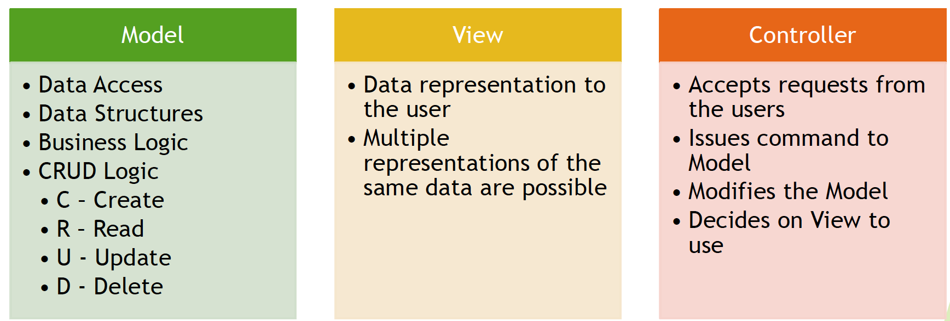

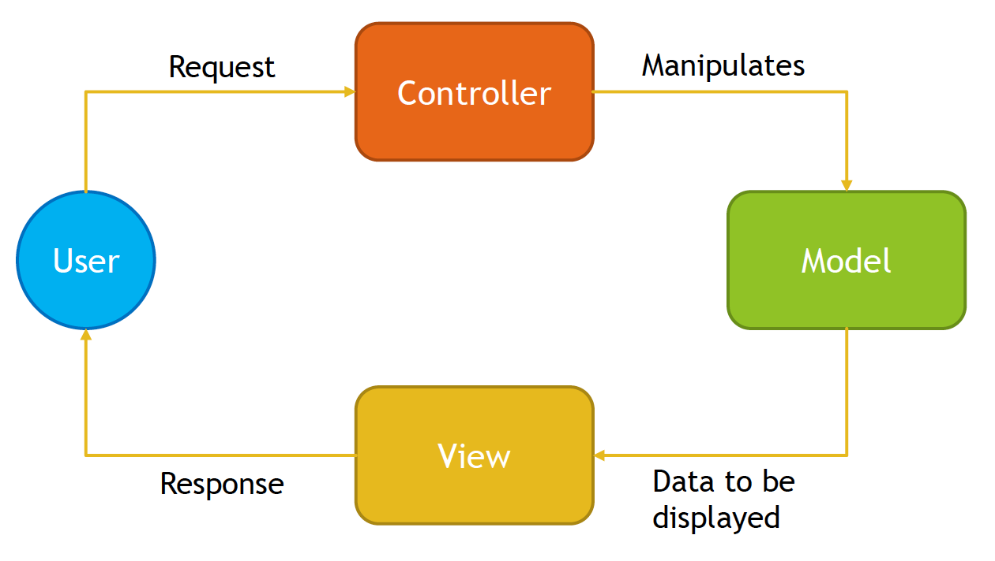

Spring MVC introduces ready to use components that you can use in your application for MVC pattern.

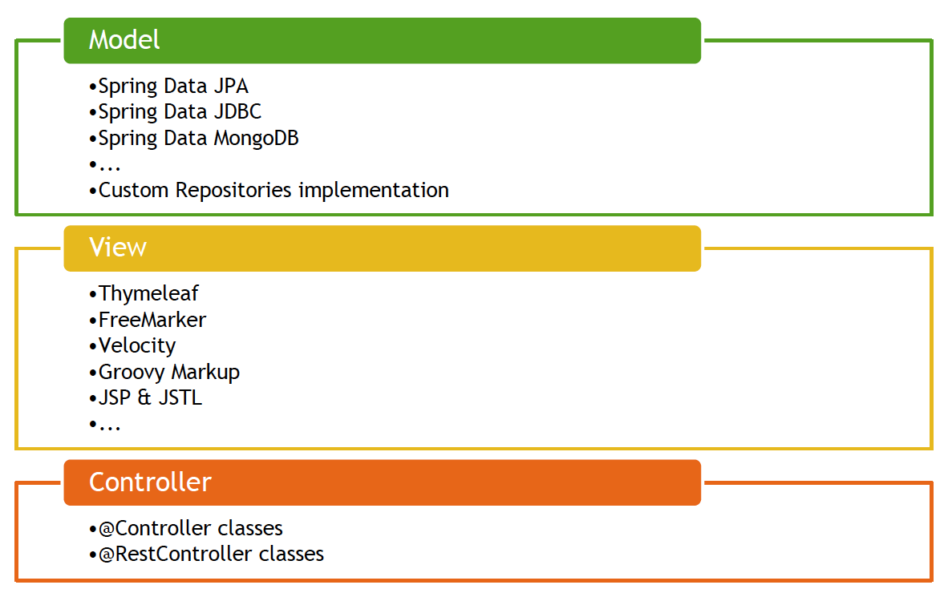

Usage of MVC design pattern has following advantages:

* Separation of concerns
* Increased code cohesion
* Increased code reusability
* Reduces coupling between data, logic and information representation
* Lowers maintenances costs
* Increases extendibility

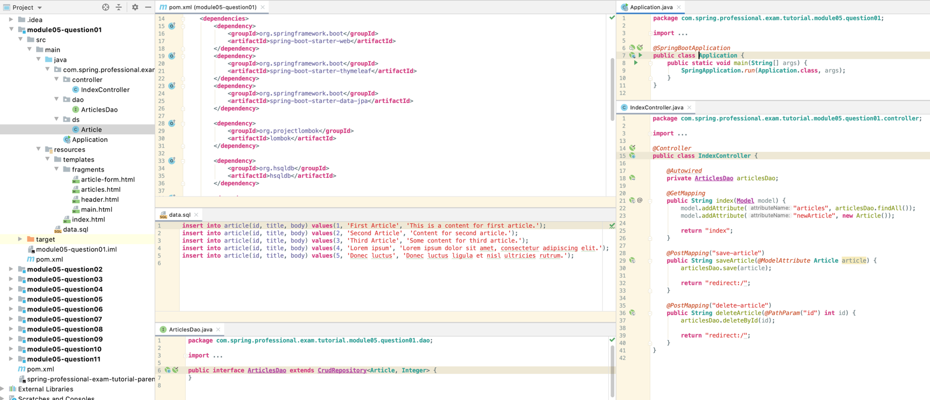

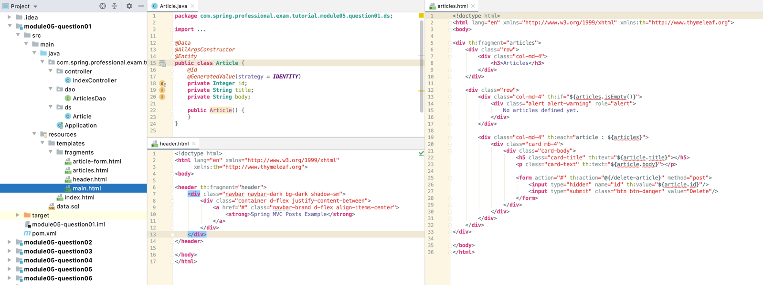

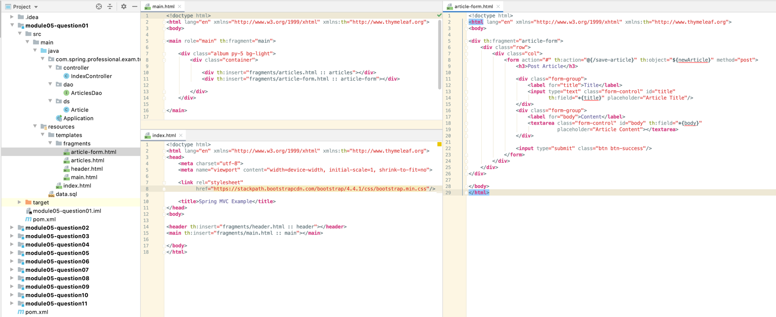

# Question 02-What is the DispatcherServlet and what is it used for?

DispatcherServlet is an internal Spring MVC component that implements HttpServlet from Java Servlet API and Front Controller Design Pattern. It is used to handle all requests to the application, based on servlet mapping, delegate those requests to controllers and produce response based on identified view.

DispatcherServlet has following responsibilities:

* Delegates received requests to Controllers
* Uses View Resolvers to resolve views pointed out by Controllers
* Produces Response that is sent to user
* Handles shared concerns, like exception mapping, error handling, security etc.

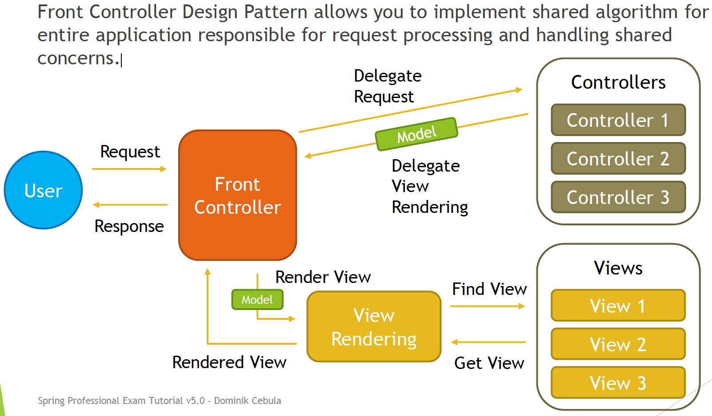

Servlet is a Java Technology used to create Web Applications on Java Platform with usage of Application Servers. It is a set of interfaces, classes and documentation allowing you to extend capabilities of Application Servers. Servlet is protocol independent, however usually it is used to process HTTP Requests with usage of custom implementation of HttpServlet class. Servlet can be registered via web.xml, or programmatically via annotations since Servlet 3. Servlet registration requires url-patterns which informs application server which requests should be mapped to your servlet.

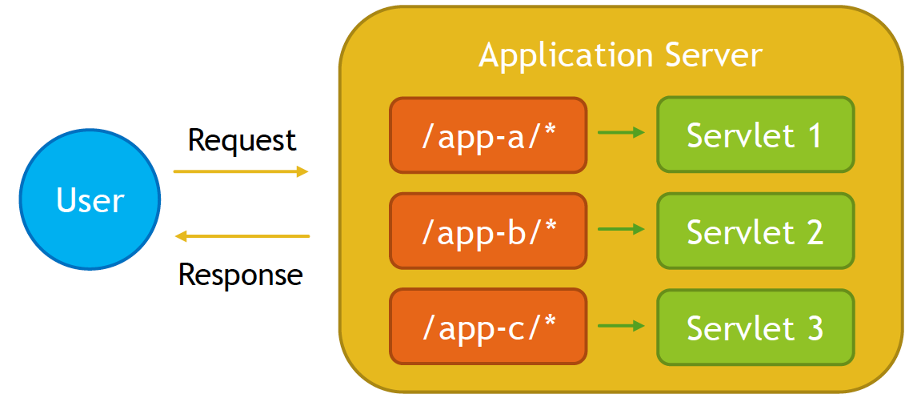

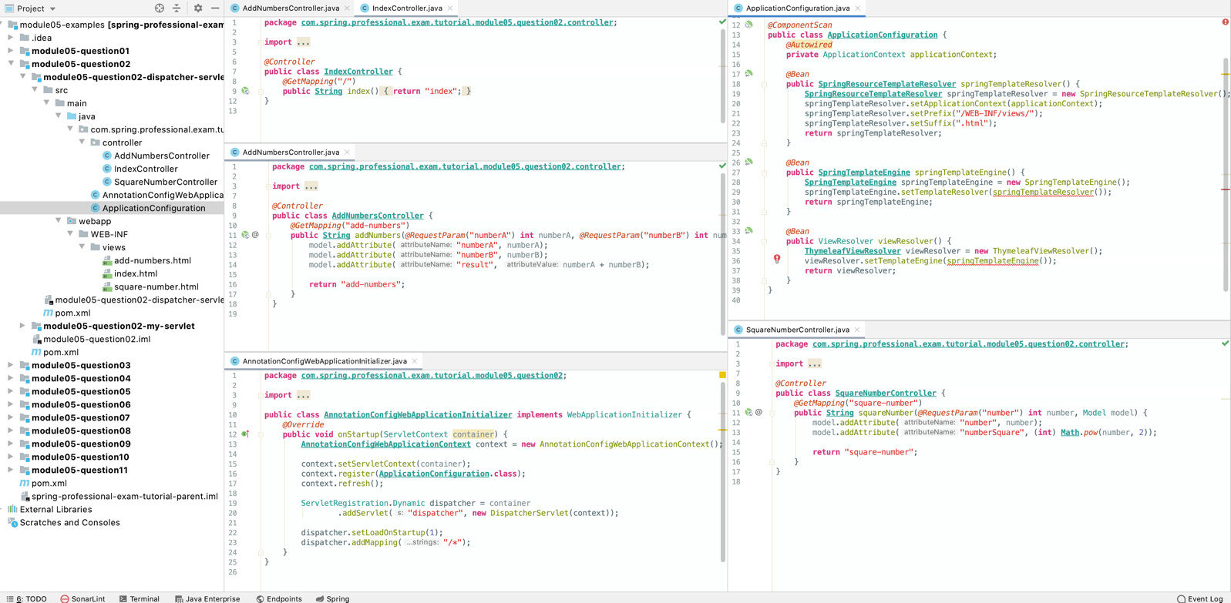

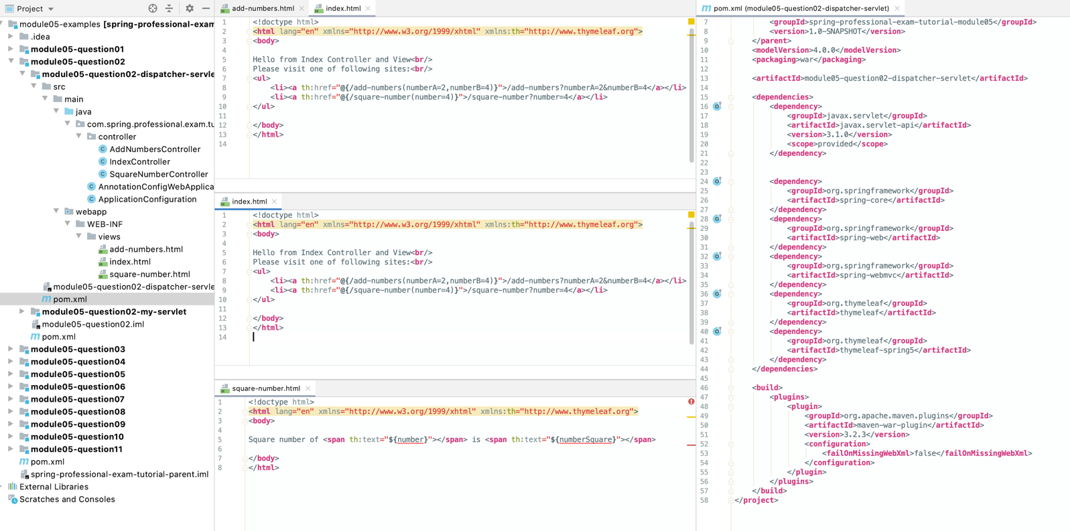

# Question 03-What is a web application context? What extra scopes does it offer?

Web Application Context is a Spring Application Context for Web Applications that runs under Embedded or Standalone Application Server that supports Servlet API and acts as Servlet Container.

Web Application Context is described by WebApplicationContext interface and it allows you to access ServletContext interface from Servlet API.

Web Application Context provides four additional scopes:

* Request Scope
* Session Scope
* Application Scope
* Websocket Scope
* Request Scope
  + Defined by @RequestScopeannotation
  + Bean lifecycle is tightly coupled with HTTP Request lifecycle
  + New Bean instance is created for each request
  + *@RequestScope  
    @Component  
    @Data***public class RequestScopeBean** {  
     **private Integer** value;  
    }
* Session Scope
* Defined by @SessionScopeannotation
* Bean lifecycle is tightly coupled with HTTP Session lifecycle
* New Bean is created for each new session and Bean instance lives as long as HTTP Session is alive
  + *@SessionScope  
    @Component  
    @Data***public class SessionScopeBean** {  
     **private Integer** value;  
    }
* Application Scope
  + Defined by @ApplicationScopeannotation
  + Bean lifecycle is tightly coupled with ServletContext
  + One Bean instance available per entire Web Application –ServletContext
  + Differences compared to Singleton Bean:
  + Singleton per ServletContext, not per Spring Application Context (one Web Application may have several Spring Application Contexts)
  + Exposed via attribute of ServletContext
  + *@ApplicationScope  
    @Component  
    @Data***public class ApplicationScopeBean** {  
     **private Integer** value;  
    }
* WebsocketScope
  + Defined by @Scope annotation with specified properties:
  + @Scope(scopeName= "websocket", proxyMode= ScopedProxyMode.TARGET_CLASS)
  + Bean lifecycle is coupled with lifecycle of WebSocket Session, however bean usually lives longer then WebSocket Session
  + 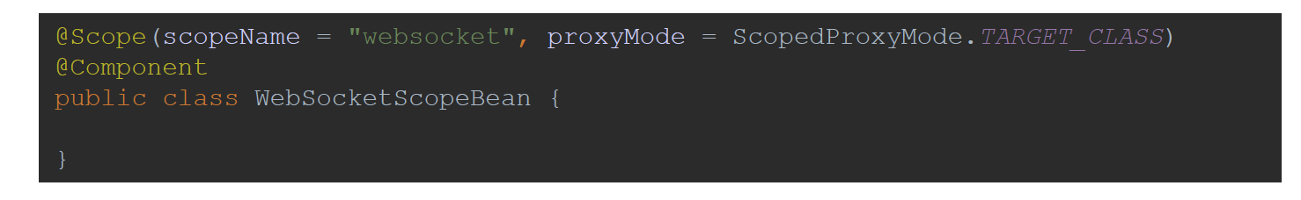

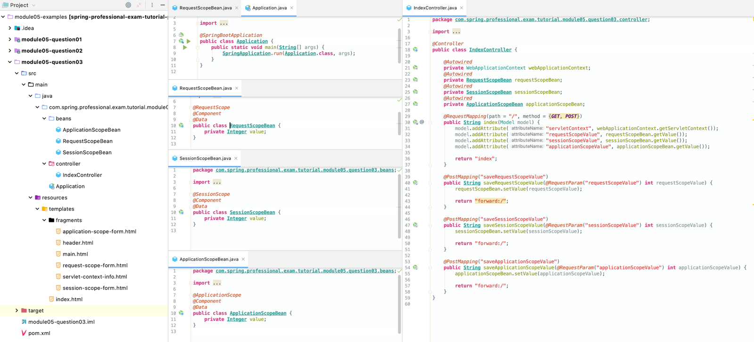

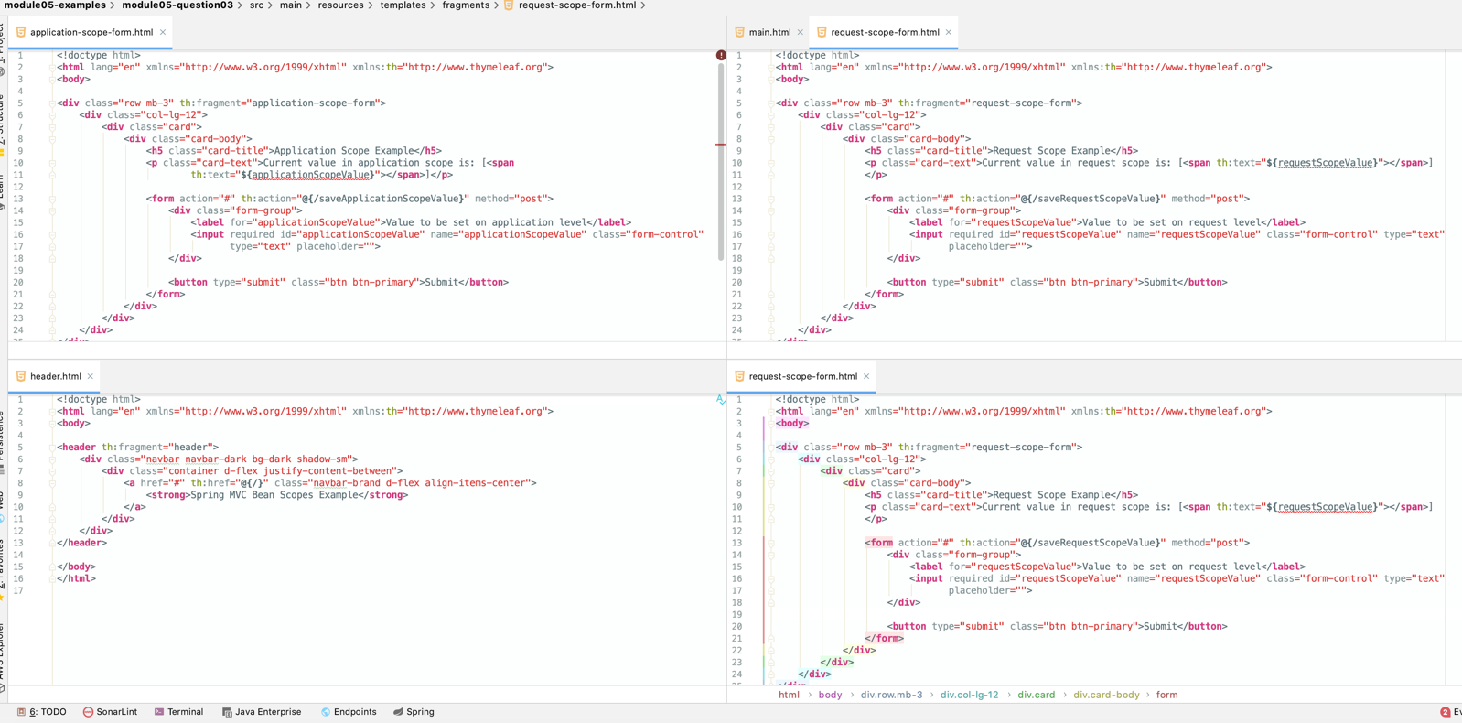

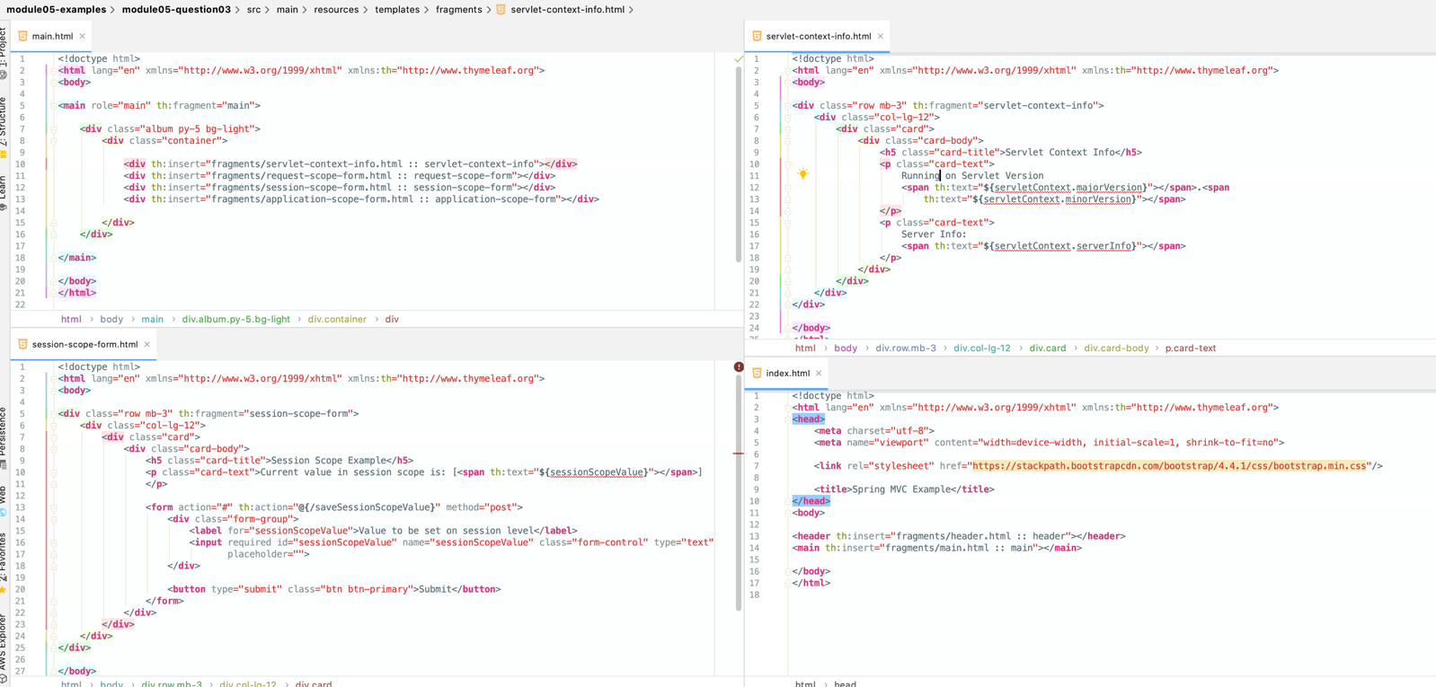

# Question 04-What is the @Controller annotation used for?

@Controller annotation is used to indicate that annotated class is a Controller from Model-View-Controller Design Pattern, and should be considered a candidate for request handling when DispatcherServlet searches for component to which work can be delegated.

@Controller annotation is a specialization of @Component annotation, this allows Spring to autodetect controllers during classpath scanning.

Controllers in Spring do not have to implement any interface or extend any base class, Spring uses annotation-based programming model with @Controller annotation being part of it. Controllers have flexible methods signatures with mapping expressed via annotations like @RequestMapping, @GetMapping, @PostMapping etc.

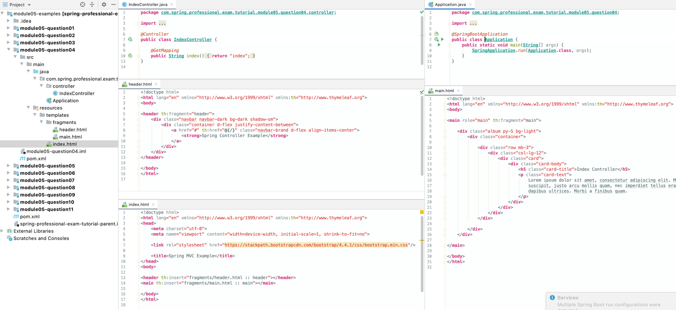

# Question 05-How is an incoming request mapped to a controller and mapped to a method?

Incoming request is mapped to a controller and a method by DispatcherServlet, which uses HandlerMapping and HandlerAdapter components for this purpose.

HandlerMapping components are used during Spring initialization to scan classpath for @Controller or @RestControllerclasses with one of request mapping annotations that are part of annotation based programming model:

* @RequestMapping
* @GetMapping
* @PostMapping
* @PutMapping
* @PatchMapping
* @DeleteMapping

HandlerAdapter components are responsible for execution of method identified as handler candidate for the request.

When request is performed against the server following steps are executed:

* 1.Application Server (Standalone or Embedded) searches for Servlet that can handle request, DispatcherServlet is selected based on Servlet Registration and url-pattern.
* 2.DispatcherServletuses HandlerMapping classes to get request mapping information and HandlerAdapter.
* 3.DispatcherServletuses HandlerAdapter to execute controller method that will handle request.
* 4.DispatcherServletinterprets results of method execution and renders View with help of ViewResolver classes.

@RequestMapping allows you to specify conditions that request has to match for a method to be used as request handler. @RequestMapping can be used at class or method level, when used at the class level, all method level mappings inherit this primary mapping, narrowing it to a specific handler method.

For example, below controllers are supposed to map GET /say/hello requests, even though request mapping is defined differently, all are equal.

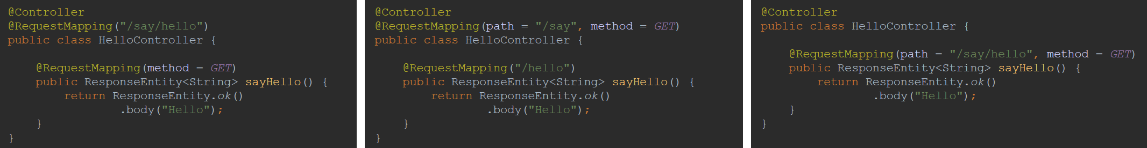

@RequestMappingannotation allows you to specify following criteria for request:

* path-uri path/paths for request, for example /api/books
* method–supported HTTP method/methods: GET, POST, HEAD, OPTIONS, PUT, PATCH, DELETE, TRACE
* params–required parameters of request, for example key1=value1, key2!=value2, key1, !key1
* headers–header needs to match specified condition, for example header1=value1, header2!=value2, header1, !header1, content-type=text/*
* consumes–media types that can be consumed by request, for example application/json
* produces–media types that are produced by method handling the request, for example application/pdf

Spring MVC also supports composed annotations for request mapping:

* @GetMapping
* @PostMapping
* @PutMapping
* @PatchMapping
* @DeleteMapping

Each of those annotations allows you to specify same conditions as @RequestMapping except for HTTP method field, following fields in @*Mapping are aliases to @RequestMapping: path, params, headers, consumes, produces.

In most of the cases it is possible to translate mappings between those annotations, one example when this is not possible is when creating HTTP HEAD request mapping.

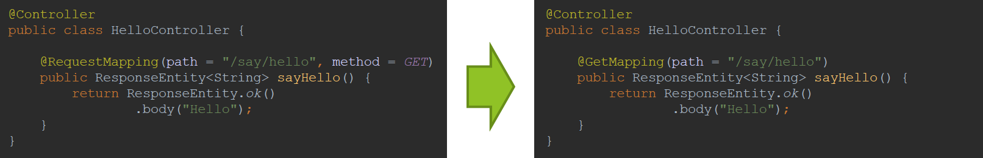

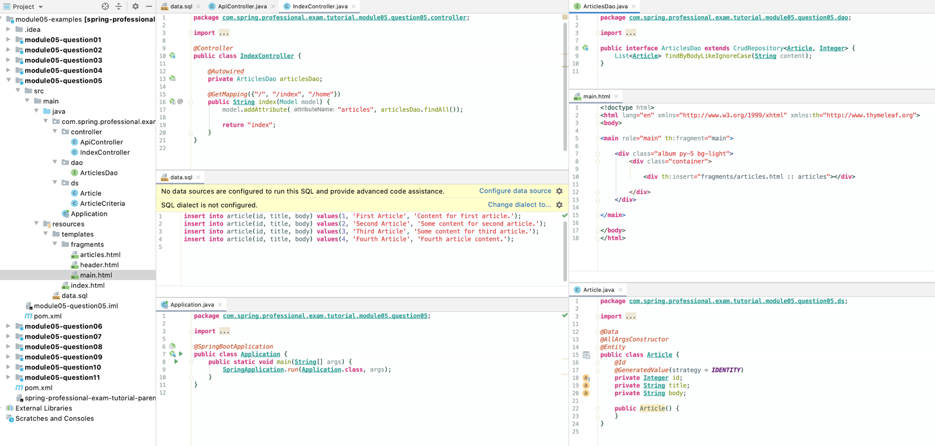

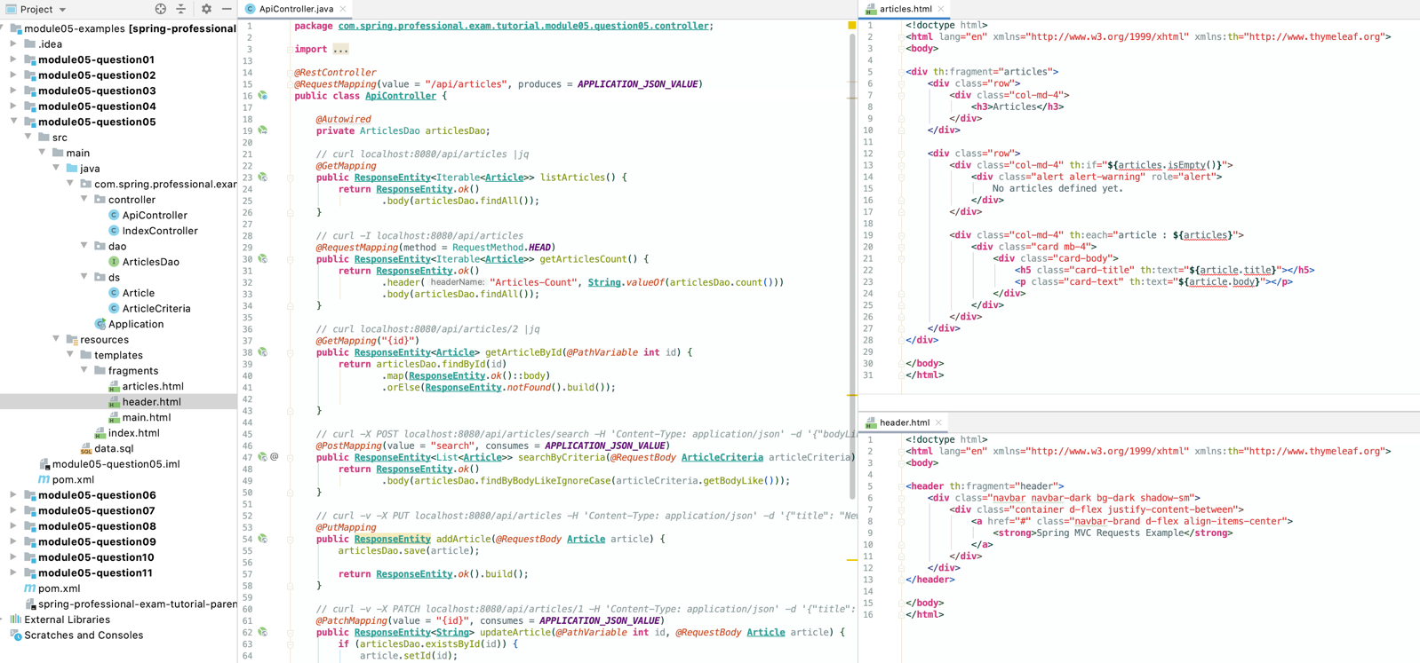

*@RestController  
@RequestMapping(*value = "/api/articles", produces = ***APPLICATION_JSON_VALUE****)***public class ApiController** *{  
  
 @Autowired* **private** ArticlesDao articlesDao;  
  
 *// curl localhost:8080/api/articles |jq  
 @GetMapping* **public ResponseEntity***<*Iterable*<***Article***>>* listArticles*() {* **return ResponseEntity**.*ok()* .body*(*articlesDao.findAll*())*;  
 *}  
  
 // curl -I localhost:8080/api/articles  
 @RequestMapping(*method = RequestMethod.***HEAD****)* **public ResponseEntity***<*Iterable*<***Article***>>* getArticlesCount*() {* **return ResponseEntity**.*ok()* .header*(*"Articles-Count", **String**.*valueOf(*articlesDao.count*()))* .body*(*articlesDao.findAll*())*;  
 *}  
  
 // curl localhost:8080/api/articles/2 |jq  
 @GetMapping(*"{id}"*)* **public ResponseEntity***<***Article***>* getArticleById*(@PathVariable* **int** id*) {* **return** articlesDao.findById*(*id*)* .map*(***ResponseEntity**.*ok()*::body*)* .orElse*(***ResponseEntity**.*notFound()*.build*())*;  
  
 *}  
// jq displays as json  
 // curl -X POST localhost:8080/api/articles/search -H 'Content-Type: application/json' -d '{"bodyLike": "%some%"}' |jq  
 @PostMapping(*value = "search", consumes = ***APPLICATION_JSON_VALUE****)* **public ResponseEntity***<*List*<***Article***>>* searchByCriteria*(@RequestBody* **ArticleCriteria** articleCriteria*) {* **return ResponseEntity**.*ok()* .body*(*articlesDao.findByBodyLikeIgnoreCase*(*articleCriteria.getBodyLike*()))*;  
 *}  
  
 // curl -v -X PUT localhost:8080/api/articles -H 'Content-Type: application/json' -d '{"title": "New article", "body": "New article content"}'  
 @PutMapping* **public ResponseEntity** addArticle*(@RequestBody* **Article** article*) {* articlesDao.save*(*article*)*;  
  
 **return ResponseEntity**.*ok()*.build*()*;  
 *}  
  
 // curl -v -X PATCH localhost:8080/api/articles/1 -H 'Content-Type: application/json' -d '{"title": "Updated article", "body": "Updated article content"}'  
 @PatchMapping(*value = "{id}", consumes = ***APPLICATION_JSON_VALUE****)* **public ResponseEntity***<***String***>* updateArticle*(@PathVariable* **int** id, *@RequestBody* **Article** article*) {* **if** *(*articlesDao.existsById*(*id*)) {* article.setId*(*id*)*;  
 articlesDao.save*(*article*)*;  
  
 **return ResponseEntity**.*ok()*.build*()*;  
 *}* **else  
 return ResponseEntity**.*notFound()*.build*()*;  
 *}  
  
 // curl -v -X DELETE localhost:8080/api/articles/3  
 @DeleteMapping(*"{id}"*)* **public ResponseEntity** deleteArticleById*(@PathVariable* **int** id*) {* **if** *(*articlesDao.existsById*(*id*)) {* articlesDao.deleteById*(*id*)*;  
  
 **return ResponseEntity**.*ok()*.build*()*;  
 *}* **else  
 return ResponseEntity**.*notFound()*.build*()*;  
 *}  
}*

# Question 06-What is the difference between @RequestMapping and @GetMapping?

The main difference between @RequestMappingand @GetMapping is that first one can be used to map any HTTP method requests and second one can be used to map only HTTP GET method requests. @GetMappingis less flexible, but easier to use.

@GetMappingannotation is a composed annotation that is equal to @RequestMapping(method = RequestMethod.GET).

Both annotations allows you to specify multiple criteria for request mapping, like uripath, required headers, consumable media types, producible media types, however only @RequestMappingallows you to specify HTTP method or HTTP methods through method field. If none HTTP methods are specified, all HTTP methods will be mapped.

Spring also includes other specialized versions of @RequestMapping:

* @PostMapping
* @PutMapping
* @DeleteMapping
* @PatchMapping

Usage of those simpler, specialized versions is recommended for simple HTTP method mappings.

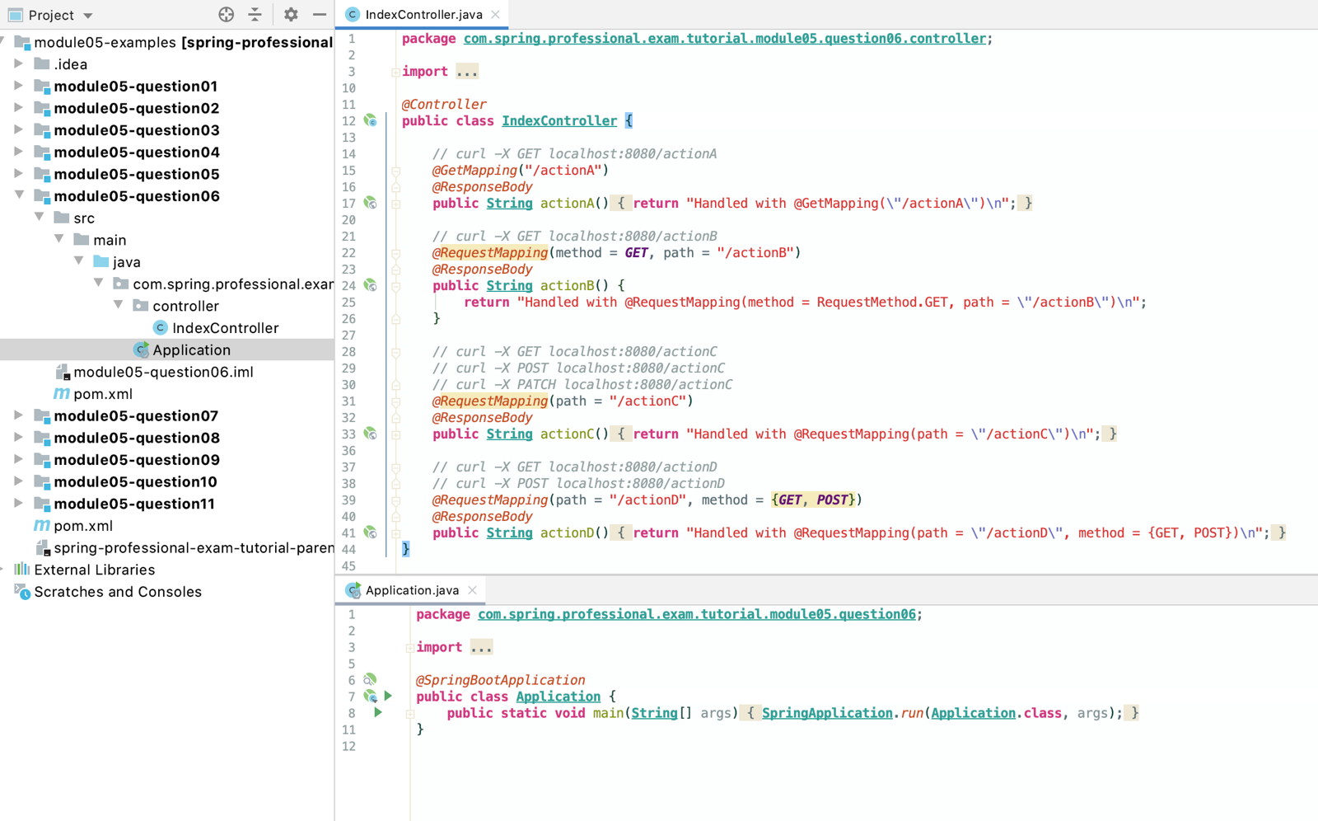

# Question 07-What is @RequestParamused for?

@RequestParam is used to bind web request parameters to controller method parameter.

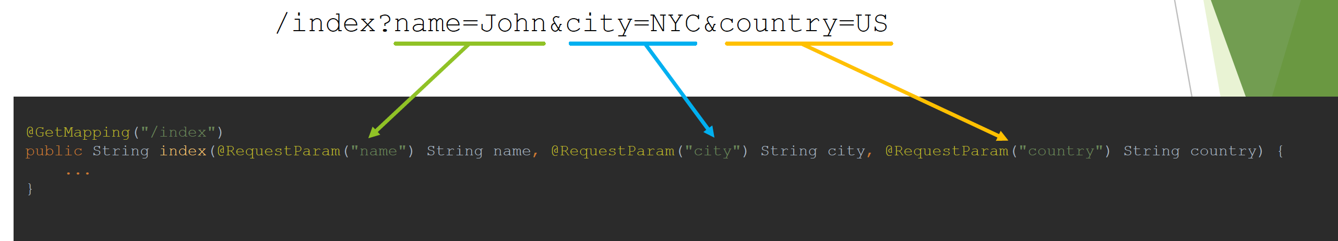

Because Servlet API combines query parameters and form data into a single parameters map, it is possible to use @RequestParamannotation to map:

* query parameters
* form data
* parts in multipart requests

@RequestParamallows you to specify following parameters:

* name–the name of request parameter to bind
* required-whether the parameter is required or not
* by default parameter is required and in case of it being absent exception will be thrown
* If switched to false, in case of parameter being absent null value will be provided or value pointed out by defaultValue property
* defaultValue–allows you to specify default value to use in case of absence of optional parameter

@RequestParamannotation also supports Java 8 Optional, so following will be equal:



@RequestParamalso supports additional use cases, like:

* Mapping all request parameters to Map
* 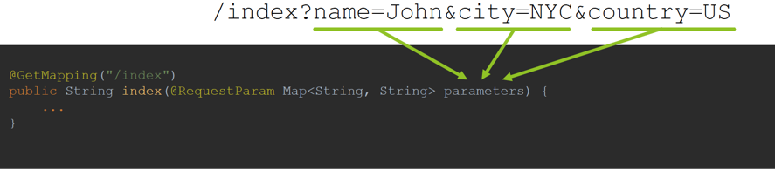
* Mapping all values to List
* 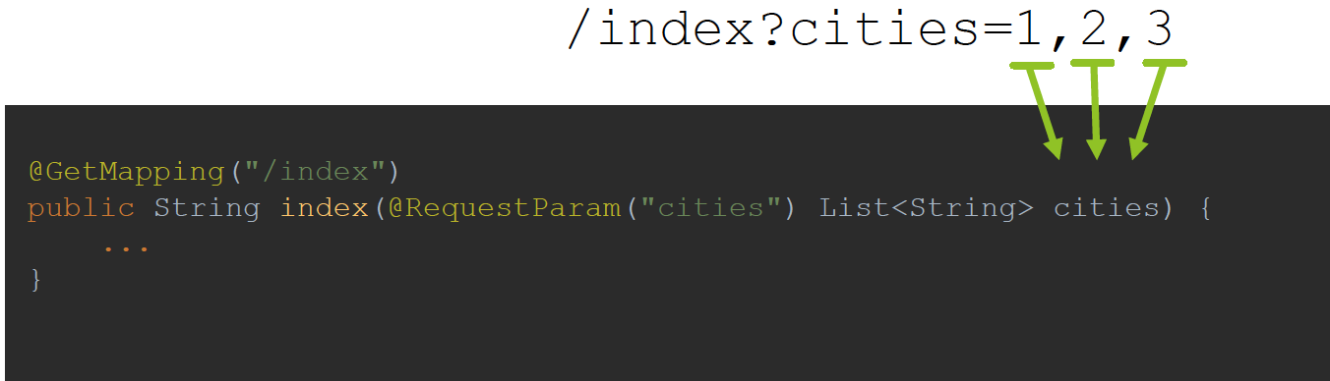

NB:

Even though @PathVariable and @RequestParam are both used to extract values from the URL, their usage is largely determined by how a site is designed.

The @PathVariable annotation is used for data passed in the URI (e.g. RESTful web services) while @RequestParam is used to extract the data found in query parameters.

# Question 08-What are the differences between @RequestParamand @PathVariable?

The main difference between @RequestParam and @PathVariable is a purpose of each annotation.

@PathVariable is responsible for mapping parts of URI, marked with usage of URI templates variables to controller method parameters. URI templates are identifiers surrounded with curly brackets.

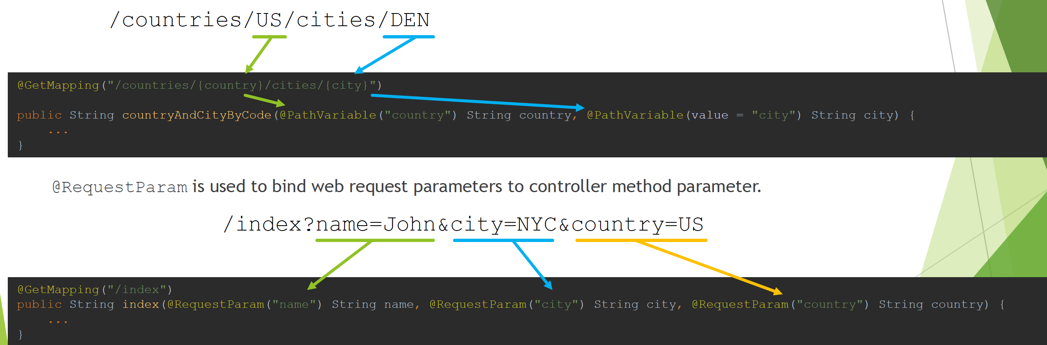

The other difference between @RequestParam and @PathVariable is following:

* @RequestParam allows you to specify defaultValue property, @PathVariable does not

Similarities are following, both allows you to:

* Specify name of variable to bind
* Mark variables as required or optional
* Use Java 8 Optional for optional values
* Map all parameters to Map
* Map list of values for parameter to collection

*@Controller***public class IndexController** *{  
  
 // curl localhost:8080/actionA/cities/ORD  
 // curl localhost:8080/actionA/cities/LAX  
 @GetMapping(*"/actionA/cities/{city}"*)  
 @ResponseBody* **public String** cityByCode*(@PathVariable(*"city"*)* **String** city*) {* **return String**.*format(*"Retrieved city = [%s]\n", city*)*;  
 *}  
  
 // curl localhost:8080/actionB/countries/US/cities/DEN  
 // curl localhost:8080/actionB/countries/PL/cities/KRK  
 @GetMapping(*"/actionB/countries/{country}/cities/{city}"*)  
 @ResponseBody* **public String** countryAndCityByCode*(@PathVariable(*"country"*)* **String** country, *@PathVariable(*value = "city"*)* **String** city*) {* **return String**.*format(*"Retrieved country = [%s], city = [%s]\n", country, city*)*;  
 *}  
  
 // curl localhost:8080/actionC/countries/US/cities/DEN  
 // curl localhost:8080/actionC/countries/US  
 @GetMapping({*"/actionC/countries/{country}/cities/{city}", "/actionC/countries/{country}"*})  
 @ResponseBody* **public String** countryAndOptionalCityByCode*(@PathVariable(*"country"*)* **String** country, *@PathVariable(*value = "city", required = **false***)* **String** city*) {* **return String**.*format(*"Retrieved name = [%s], city = [%s]\n", country, city*)*;  
 *}  
  
 // curl localhost:8080/actionD/countries/US/cities/DEN  
 // curl localhost:8080/actionD/countries/US  
 @GetMapping({*"/actionD/countries/{country}/cities/{city}", "/actionD/countries/{country}"*})  
 @ResponseBody* **public String** countryAndOptionalCityByCodeJava8*(@PathVariable(*"country"*)* **String** country, *@PathVariable(*value = "city"*)* **Optional***<***String***>* city*) {* **return String**.*format(*"Retrieved name = [%s], city = [%s]\n", country, city.orElse*(*"N/A"*))*;  
 *}  
  
 // curl localhost:8080/actionE/countries/US/cities/DFW/zip/75038  
 @GetMapping(*"/actionE/countries/{country}/cities/{city}/zip/{code}"*)  
 @ResponseBody* **public String** actionE*(@PathVariable* Map*<***String**, **String***>* parameters*) {* **String** parametersAsString = parameters.entrySet*()*.stream*()* .map*(*entry -> **String**.*format(*"[%s] -> [%s]", entry.getKey*()*, entry.getValue*()))* .collect*(***Collectors**.*joining(*", "*))*;  
  
 **return String**.*format(*"Retrieved parameters map = [%s]\n", parametersAsString*)*;  
 *}  
  
 // curl localhost:8080/actionF/countries/US,PL,UK  
 @GetMapping(*"/actionF/countries/{countries}"*)  
 @ResponseBody* **public String** actionF*(@PathVariable(*"countries"*)* List*<***String***>* countries*) {* **return String**.*format(*"Retrieved cities identifiers = [%s]\n", **String**.*join(*", ", countries*))*;  
 *}  
}*

# Question 09-What are some of the parameter types for a controller method?

WebRequest, NativeWebRequest–Access to HTTP request details, parameters, also request and session attributes, without direct use of the Servlet API

*@Controller***public class Example01WebRequest** *{  
 // curl "localhost:8080/actionA?name=John&country=US"  
 @GetMapping(*"/actionA"*)  
 @ResponseBody* **public String** actionA*(*WebRequest webRequest*) {* **return String**.*format(* "Retrieved request with headers = [%s], parameters = [%s]\n",  
 *join(*webRequest.getHeaderNames*())*,  
 *join(*webRequest.getParameterNames*())  
 )*;  
 *}  
}*

*@Controller***public class Example02NativeWebRequest** *{  
 // curl "localhost:8080/actionB?name=John&country=US"  
 @GetMapping(*"/actionB"*)  
 @ResponseBody* **public void** actionB*(*NativeWebRequest nativeWebRequest*)* **throws IOException** *{* **RequestFacade** requestFacade = nativeWebRequest.getNativeRequest*(***RequestFacade**.**class***)*;  
 **ResponseFacade** responseFacade = nativeWebRequest.getNativeResponse*(***ResponseFacade**.**class***)*;  
  
 responseFacade.getOutputStream*()*.println*(  
 format(* "Retrieved request with headers = [%s], parameters = [%s]",  
 *join(*requestFacade.getHeaderNames*())*,  
 *join(*requestFacade.getParameterNames*())  
 )  
 )*;  
 *}  
}*

javax.servlet.ServletRequest-object to provide client request information, allows access to parameters, attributes and other request details without direct use of Spring Interfaces

*@Controller***public class Example03ServletRequest** *{  
 // curl localhost:8080/actionC  
 @GetMapping(*"/actionC"*)  
 @ResponseBody* **public String** actionC*(*ServletRequest servletRequest*) {* **return** *format(*"Retrieved request on server = [%s:%d]\n",   
 servletRequest.getServerName*()*, servletRequest.getServerPort*())*; *//localhost:8080  
 }  
}*

javax.servlet.ServletResponse–object created by servlet container, passed to service method of servlet, used by servlet to send a response to the client

*@Controller***public class Example04ServletRequestAndResponse** *{  
 // curl localhost:8080/actionD  
 @GetMapping(*"/actionD"*)  
 @ResponseBody* **public void** actionD*(*ServletRequest servletRequest, ServletResponse servletResponse*)* **throws IOException** *{* servletResponse.getOutputStream*()*.println*(  
 format(*"Retrieved request on server = [%s:%d]", servletRequest.getServerName*()*, servletRequest.getServerPort*())  
 )*;  
 *}  
}*

javax.servlet.http.HttpSession–allows access to session information and attributes, also enforces HTTP session for request

*@Controller***public class Example05HttpSession** *{  
 // curl -c cookie.txt -b cookie.txt localhost:8080/actionE  
 @GetMapping(*"/actionE"*)  
 @ResponseBody* **public String** actionE*(*HttpSession httpSession*) {* **Integer** counter = *(***Integer***)* httpSession.getAttribute*(*"counter"*)*;  
 **if** *(*counter == **null***) {* httpSession.setAttribute*(*"counter", 0*)*;  
 counter = 0;  
 *}* httpSession.setAttribute*(*"counter", ++counter*)*;  
  
 **return** *format(*"Counter = [%d]\n", counter*)*;  
 *}  
}  
  
//# Netscape HTTP Cookie File  
// # https://curl.haxx.se/docs/http-cookies.html  
// # This file was generated by libcurl! Edit at your own risk.  
//  
// #HttpOnly_localhost FALSE / FALSE 0 JSESSIONID 161DDE9173B393E0E15FACDDD0DE8DE8*

javax.servlet.http.PushBuilder-Servlet 4.0 push builder API for programmatic HTTP/2 resource pushes, allows resources to be delivered in advance by the server, resulting in a faster load time

*@Controller***public class Example06PushBuilder** *{  
 // Visit http://localhost:8080/actionF/no-push in your browser  
 @GetMapping(*"/actionF/no-push"*)* **public String** actionFNoPush*() {* **return** "images";  
 *}  
  
 // Visit https://localhost:8443/actionF/with-push in your browser  
 @GetMapping(*"/actionF/with-push"*)* **public String** actionFWithPush*(*PushBuilder pushBuilder*) {* **if** *(*pushBuilder != **null***) {* pushBuilder.path*(*"/img/b-module02.jpg"*)*.push*()*;  
 pushBuilder.path*(*"/img/b-module05.jpg"*)*.push*()*;  
 pushBuilder.path*(*"/img/b-module08.jpg"*)*.push*()*;  
 *}* **return** "images";  
 *}  
}*

*<!doctype* html*>  
<***html** th:replace="*~{*layout :: layout*(~{*::main*})}*" xmlns="http://www.w3.org/1999/xhtml"  
 xmlns:th="http://www.thymeleaf.org"*>  
<***body***>  
<***main** role="main"*>  
  
 <***div** class="album py-5 bg-light"*>  
 <***div** class="container"*>  
  
 <***p***>*Image below can be send via HTTP/1.x Pull approach or HTTP/2 Push.*</***p***>  
 <***img** width="128" height="128" src="/img/b-module02.jpg"*/>  
 <***img** width="128" height="128" src="/img/b-module05.jpg"*/>  
 <***img** width="128" height="128" src="/img/b-module08.jpg"*/>  
  
 </***div***>  
 </***div***>  
  
</***main***>  
</***body***>  
</***html***>*

java.security.Principal-currently authenticated user

*@Controller***public class Example07Principal** *{  
 // Visit http://localhost:8080/actionG in your browser  
 // use john/john or mary/mary as username and password  
 @GetMapping(*"/actionG"*)  
 @ResponseBody* **public String** actionG*(*Principal principal*) {* **return** *format(*"Authenticated with principal = [%s]\n", principal.getName*())*;  
 *}  
}*

*@Configuration  
@EnableWebSecurity***public class WebSecurityConfig extends WebSecurityConfigurerAdapter** *{  
 @Autowired* **public void** configureGlobal*(***AuthenticationManagerBuilder** auth*)* **throws Exception** *{* auth.inMemoryAuthentication*()* .withUser*(*"john"*)* .password*(*passwordEncoder*()*.encode*(*"john"*))* .roles*(*"USER"*)* .and*()* .withUser*(*"mary"*)* .password*(*passwordEncoder*()*.encode*(*"mary"*))* .roles*(*"USER"*)*;  
 *}  
  
 @Override* **protected void** configure*(***HttpSecurity** http*)* **throws Exception** *{* http.authorizeRequests*()* .antMatchers*(*"/actionG"*)*.authenticated*()* .antMatchers*(*"/*"*)*.permitAll*()* .and*()* .csrf*()*.disable*()* .httpBasic*()* .realmName*(*"Spring Tutorial"*)*;  
 *}  
  
 @Bean* **public** PasswordEncoder passwordEncoder*() {* **return new** BCryptPasswordEncoder*()*;  
 *}  
}*

*<***dependency***>  
 <***groupId***>*org.springframework.boot*</***groupId***>  
 <***artifactId***>*spring-boot-starter-security*</***artifactId***>  
</***dependency***>*

HttpMethod–HTTP method used for request, one of GET, HEAD, POST, PUT, PATCH, DELETE, OPTIONS, TRACE

*@Controller***public class Example08HttpMethod** *{  
 // curl -X GET localhost:8080/actionH  
 // curl -X POST localhost:8080/actionH  
 // curl -X PUT localhost:8080/actionH  
 @RequestMapping(*"/actionH"*)  
 @ResponseBody* **public String** actionH*(*HttpMethod httpMethod*) {* **return** *format(*"HTTP Method = [%s]\n", httpMethod*)*;  
 *}  
}*

java.util.Locale-request locale, determined by the most specific LocaleResolver available

*@Controller***public class Example09Locale** *{  
 // curl -H "Accept-Language: en" localhost:8080/actionI  
 // curl -H "Accept-Language: es" localhost:8080/actionI  
 // curl -H "Accept-Language: pl" localhost:8080/actionI  
 @RequestMapping(*"/actionI"*)  
 @ResponseBody* **public String** actionI*(***Locale** locale*) {* **return** *format(*"Locale = [%s]\n", locale.getDisplayName*())*;  
 *}  
}*

java.util.TimeZone+ java.time.ZoneId-time zone associated with the current request, as determined by a LocaleContextResolver.

*@Controller***public class Example10TimeZone** *{  
 // curl localhost:8080/actionJ  
 @RequestMapping(*"/actionJ"*)  
 @ResponseBody* **public String** actionJ*(***TimeZone** timeZone, **ZoneId** zoneId*) {* **return** *format(*"TimeZone = [%s], ZoneId = [%s]\n", timeZone.getDisplayName*()*, zoneId.getId*())*;  
 *}  
}*

java.io.InputStream, java.io.Reader – allows access to raw request body as exposed by the Servlet API

java.io.OutputStream, java.io.Writer – allows to create raw response as exposed by the Servlet API

*@Controller***public class Example11Streams** *{  
 // curl -X POST -H "Content-Type: application/octet-stream" -d "{ request body content }" localhost:8080/actionK  
 @RequestMapping(*"/actionK"*)  
 @ResponseBody* **public void** actionK*(***InputStream** inputStream, **OutputStream** outputStream*)* **throws IOException** *{* inputStream.transferTo*(*outputStream*)*;  
 outputStream.write*(*10*)*;  
 *}  
}*

HttpEntity<B> -container object that exposes request headers and body, body is converted with usage of HttpMessageConverter

*@Controller***public class Example12HttpEntity** *{  
 // curl -X POST -H 'Content-Type: application/json' -d '{ "firstName": "John", "lastName": "Doe", "streetAddress": "455 Larkspur Dr. Apt 23", "city": "Baviera", "stateCode": "CA", "zipCode": "92908", "country": "United States" }' localhost:8080/actionL  
 @PostMapping(*"/actionL"*)  
 @ResponseBody* **public String** actionL*(***HttpEntity***<***Address***>* httpEntity*) {* **return** *format(* "Received request from host = [%s],\nAddress = [%s]\n",  
 httpEntity.getHeaders*()*.getHost*()*,  
 httpEntity.getBody*()  
 )*;  
 *}  
}*

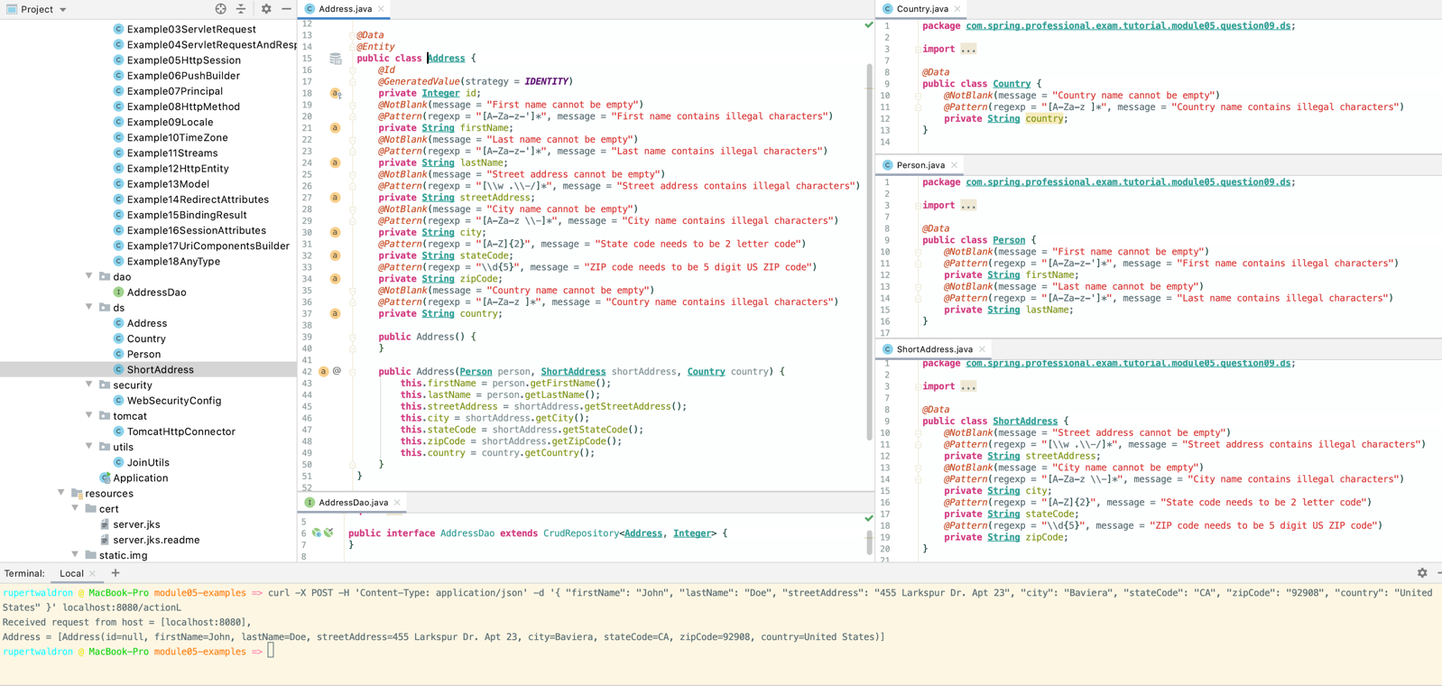

java.util.Map, org.springframework.ui.Model, org.springframework.ui.ModelMap –used to expose data to templates as part of view rendering

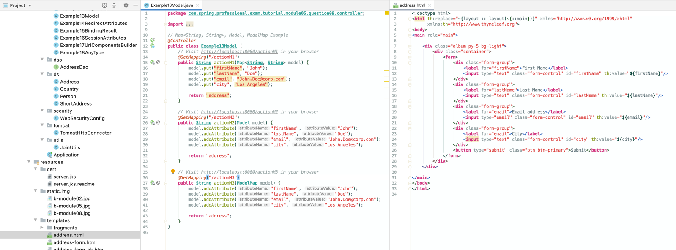

RedirectAttributes–specify attributes to use in case of redirect, regular attributes will be added to query string and flash attributes will be kept temporarily until end of request, flash attributes are kept typically in the session and are removed immediately after request is completed

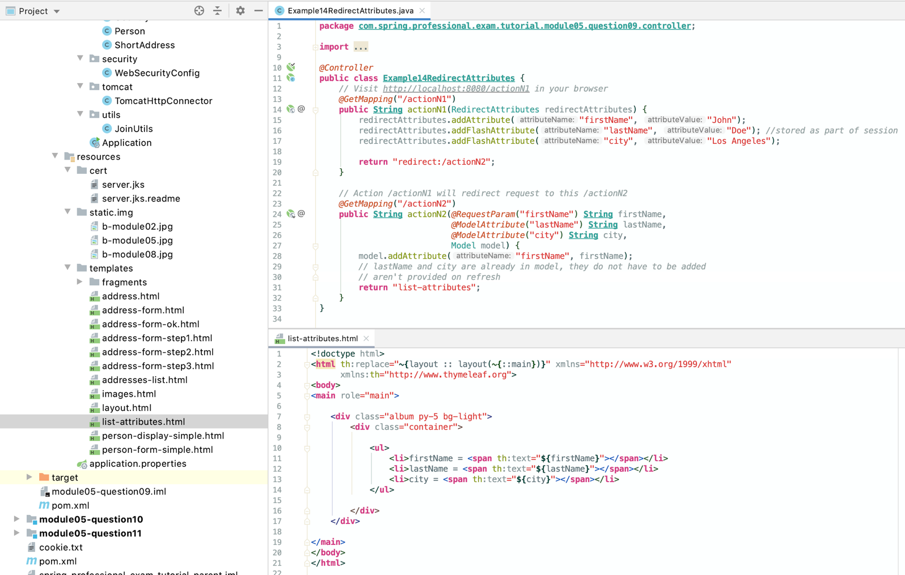

Errors, BindingResult–used to gain access to form validation and binding data results, can be used with @ModelAttribute, @RequestBodyor @RequestPartargument, Errors and BindingResultargument must be declared immediately after the validated method argument

*@Controller***public class Example15BindingResult** *{  
 // Visit http://localhost:8080/actionO1 in your browser  
 @GetMapping(*"/actionO1"*)* **public String** actionO1*(@ModelAttribute* **Address** address*) {* **return** "address-form";  
 *}  
  
 // This endpoint will be used by actionO1 to submit data that contains address:  
 // John Doe  
 // 455 Larkspur Dr. Apt 23  
 // Baviera CA 92908 United States  
 @PostMapping(*"/actionO1"*)* **public String** actionO1Submit*(@ModelAttribute @Valid* **Address** address, BindingResult bindingResult, RedirectAttributes redirectAttributes*) {* **if** *(*bindingResult.hasErrors*()) {* **return** "address-form";  
 *}* redirectAttributes.addFlashAttribute*(*address*)*;  
 **return** "redirect:/actionO1/ok";  
 *}  
  
 // This endpoint will be used by actionO1 when data was submitted successfully  
 @GetMapping(*"/actionO1/ok"*)* **public String** actionO1Ok*(@ModelAttribute* **Address** address*) {* **return** "address-form-ok";  
 *}  
}*

SessionStatus+ class-level @SessionAttributes–useful for multi step form processing, @SessionAttributesallows to keep @ModelAttributeobjects between requests and SessionStatus allows to clean session variables when form processing is done

*// SessionStatus + class-level @SessionAttributes with multi step form processing  
@Controller  
@SessionAttributes({*"person", "shortAddress", "country"*}) //holds these values in Session***public class Example16SessionAttributes** *{  
  
 @Autowired* **private** AddressDao addressDao;  
  
 *// Visit http://localhost:8080/actionP in your browser  
 @GetMapping(*"/actionP"*)* **public String** actionP*(*Model model*) {* model.addAttribute*(*"addresses", addressDao.findAll*())*;  
  
 **return** "addresses-list";  
 *}  
  
 // This is a first step in multi step address submission  
 @GetMapping(*"/actionP/address/step1"*)* **public String** actionPStep1*(@ModelAttribute(*"person"*)* **Person** person*) {* **return** "address-form-step1";  
 *}  
  
 // This is a post submission method for first step of multi step address submission  
 @PostMapping(*"/actionP/address/step1"*)* **public String** actionPStep1*(@ModelAttribute(*"person"*) @Valid* **Person** person, BindingResult bindingResult*) {* **if** *(*bindingResult.hasErrors*())* **return** "address-form-step1";  
 **else  
 return** "redirect:/actionP/address/step2";  
 *}  
  
 // This is a second step in multi step address submission  
 @GetMapping(*"/actionP/address/step2"*)* **public String** actionPStep2*(@ModelAttribute(*"shortAddress"*)* **ShortAddress** shortAddress*) {* **return** "address-form-step2";  
 *}  
  
 // This is a post submission method for second step of multi step address submission  
 @PostMapping(*"/actionP/address/step2"*)* **public String** actionPStep2*(@ModelAttribute(*"shortAddress"*) @Valid* **ShortAddress** shortAddress,  
 BindingResult bindingResult*) {* **if** *(*bindingResult.hasErrors*())* **return** "address-form-step2";  
 **else  
 return** "redirect:/actionP/address/step3";  
 *}  
  
 // This is a third step in multi step address submission  
 @GetMapping(*"/actionP/address/step3"*)* **public String** actionPStep3*(@ModelAttribute(*"country"*)* **Country** country*) {* **return** "address-form-step3";  
 *}  
  
 // This is a post submission method for third step of multi step address submission  
 @PostMapping(*"/actionP/address/step3"*)* **public String** actionPStep2*(@ModelAttribute(*"country"*) @Valid* **Country** country, BindingResult bindingResult,  
 *@ModelAttribute(*"shortAddress"*)* **ShortAddress** shortAddress,  
 *@ModelAttribute(*"person"*)* **Person** person, SessionStatus sessionStatus*) {* **if** *(*bindingResult.hasErrors*())* **return** "address-form-step3";  
 **else** *{* **Address** address = **new** Address*(*person, shortAddress, country*)*;  
 addressDao.save*(*address*)*;  
 sessionStatus.setComplete*()*;  
  
 **return** "redirect:/actionP";  
 *}  
 }  
  
 @ModelAttribute(*"person"*)* **public Person** person*() {* **return new** Person*()*;  
 *}  
  
 @ModelAttribute(*"shortAddress"*)* **public ShortAddress** shortAddress*() {* **return new** ShortAddress*()*;  
 *}  
  
 @ModelAttribute(*"country"*)* **public Country** country*() {* **return new** Country*()*;  
 *}*

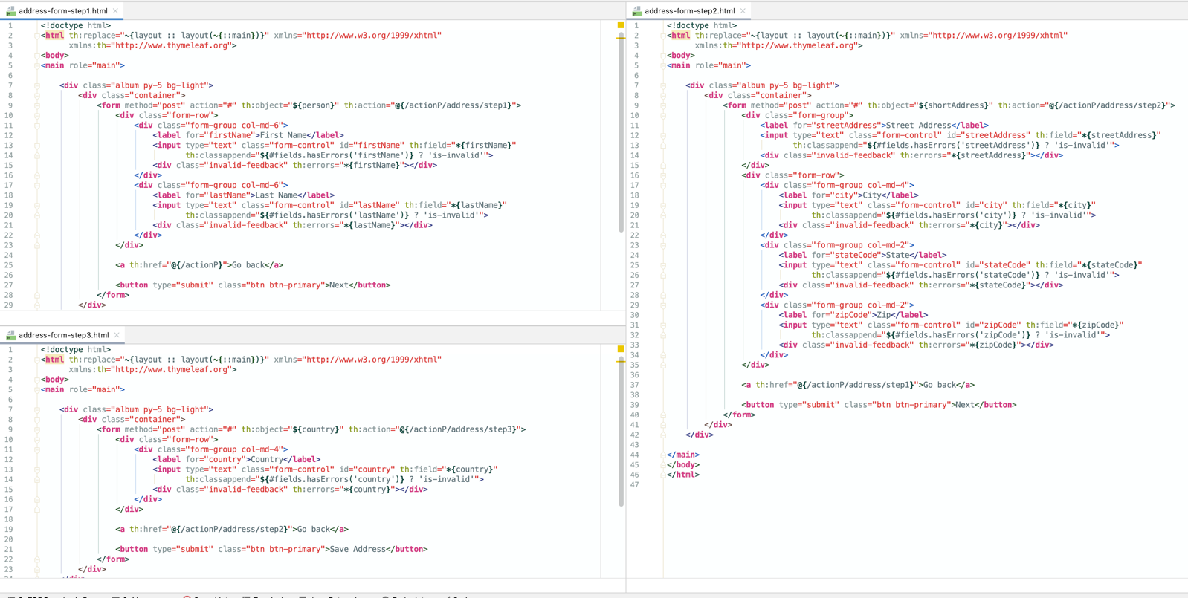

UriComponentsBuilder–used to build URLs relative to current scheme, host, port, contextPath etc.

*@Controller***public class Example17UriComponentsBuilder** *{  
 // curl "http://localhost:8080/actionR?firstName=John&lastName=Doe"  
 @GetMapping(*"/actionR"*)  
 @ResponseBody* **public String** actionR*(*HttpServletRequest request*) {* **UriComponents** uriComponents = **UriComponentsBuilder**.*fromHttpUrl(*request.getRequestURL*()*.toString*()* + "?" + request.getQueryString*())* .scheme*(*"https"*)* .path*(*"/differentAction"*)* .replaceQueryParam*(*"lastName", "Smith"*)* .build*()*;  
  
 **return String**.*format(* "Created request from original request = [%s]\n",  
 uriComponents.toString*()  
 )*;  
 *//Created request from original request = [https://localhost:8080/actionR/differentAction?firstName=John&lastName=Smith]  
 }  
}*

Any other argument–if a method argument is not matched against types defined before, and it is a simply type, it is treated as @RequestParam, if it is a complex type, it is treated as @ModelAttribute

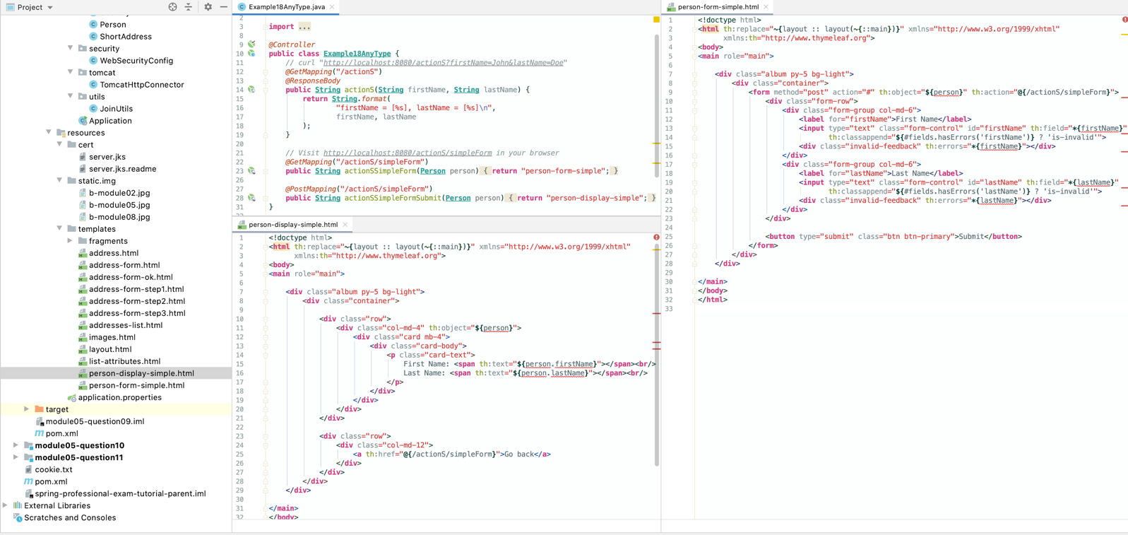

# Question 10-What other annotations might you use on a controller method parameter?

@RequestParam-access to the Servlet request parameters, including multipart files, parameters will be automatically converted to declared method argument types, parameters can be made optional with usage of required attribute or Optional from Java 8, for optional request parameters defaultValue can be set as well

*@Controller***public class Example01RequestParam** *{  
  
 // curl "http://localhost:8080/example01A?firstName=John&lastName=Doe"  
 @GetMapping(*"/example01A"*)  
 @ResponseBody* **public String** example01A*(@RequestParam(*"firstName"*)* **String** firstName, *@RequestParam(*"lastName"*)* **String** lastName*) {* **return String**.*format(*"Received firstName = [%s], lastName = [%s]\n", firstName, lastName*)*;  
 *}  
  
 // curl "http://localhost:8080/example01B?firstName=John&lastName=Doe"  
 // curl "http://localhost:8080/example01B?firstName=John"  
 @GetMapping(*"/example01B"*)  
 @ResponseBody* **public String** example01B*(@RequestParam(*"firstName"*)* **String** firstName, *@RequestParam(*value = "lastName", required = **false***)* **String** lastName*) {* **return String**.*format(*"Received firstName = [%s], lastName = [%s]\n", firstName, lastName*)*;  
 *}  
  
 // curl "http://localhost:8080/example01C?firstName=John&lastName=Doe"  
 // curl "http://localhost:8080/example01C?firstName=John"  
 @GetMapping(*"/example01C"*)  
 @ResponseBody* **public String** example01C*(@RequestParam(*"firstName"*)* **String** firstName, *@RequestParam(*value = "lastName", required = **false**, defaultValue = "N/A"*)* **String** lastName*) {* **return String**.*format(*"Received firstName = [%s], lastName = [%s]\n", firstName, lastName*)*;  
 *}  
  
 // curl "http://localhost:8080/example01D?firstName=John&lastName=Doe"  
 // curl "http://localhost:8080/example01D?firstName=John"  
 @GetMapping(*"/example01D"*)  
 @ResponseBody* **public String** example01D*(@RequestParam(*"firstName"*)* **String** firstName, *@RequestParam(*value = "lastName"*)* **Optional***<***String***>* lastName*) {* **return String**.*format(*"Received firstName = [%s], lastName = [%s]\n", firstName, lastName.orElse*(*"N/A"*))*;  
 *}  
}*

@PathVariable–access to URI template variables, parameters can be made optional with usage of required attribute or Optional from Java 8

*@Controller***public class Example02PathVariable** *{  
  
 // curl http://localhost:8080/example02A/firstName/John/lastName/Doe  
 @GetMapping(*"/example02A/firstName/{firstName}/lastName/{lastName}"*)  
 @ResponseBody* **public String** example02A*(@PathVariable(*"firstName"*)* **String** firstName, *@PathVariable(*"lastName"*)* **String** lastName*) {* **return String**.*format(*"Received firstName = [%s], lastName = [%s]\n", firstName, lastName*)*;  
 *}  
  
 // curl http://localhost:8080/example02B/firstName/John/lastName/Doe  
 // curl http://localhost:8080/example02B/firstName/John  
 @GetMapping({* "/example02B/firstName/{firstName}/lastName/{lastName}",  
 "/example02B/firstName/{firstName}"  
 *})  
 @ResponseBody* **public String** example02B*(@PathVariable(*"firstName"*)* **String** firstName, *@PathVariable(*value = "lastName", required = **false***)* **String** lastName*) {* **return String**.*format(*"Received firstName = [%s], lastName = [%s]\n", firstName, lastName*)*;  
 *}  
  
 // curl http://localhost:8080/example02C/firstName/John/lastName/Doe  
 // curl http://localhost:8080/example02C/firstName/John  
 @GetMapping({* "/example02C/firstName/{firstName}/lastName/{lastName}",  
 "/example02C/firstName/{firstName}"  
 *})  
 @ResponseBody* **public String** example02C*(@PathVariable(*"firstName"*)* **String** firstName, *@PathVariable(*value = "lastName"*)* **Optional***<***String***>* lastName*) {* **return String**.*format(*"Received firstName = [%s], lastName = [%s]\n", firstName, lastName.orElse*(*"N/A"*))*;  
 *}  
}*

@MatrixVariable-access to name-value pairs in URI path segments as described in RFC 3986, allows mapping variables from requests like /employees/id=1;name=John

*@Controller***public class Example03MatrixVariable** *{  
 // curl http://localhost:8080/example03A/employees/id=1  
 @GetMapping(*"/example03A/employees/{id}"*)  
 @ResponseBody* **public String** example03A*(@MatrixVariable(*"id"*)* **int** id*) {* **return String**.*format(*"Received request id = [%d]\n", id*)*;  
 *}  
  
 // curl "http://localhost:8080/example03B/employees/id=1;name=John"  
 @GetMapping(*"/example03B/employees/{employee}"*)  
 @ResponseBody* **public String** example03B*(@MatrixVariable(*"id"*)* **int** id, *@MatrixVariable(*"name"*)* **String** name*) {* **return String**.*format(*"Received request id = [%d], name = [%s]\n", id, name*)*;  
 *}  
  
 // curl "http://localhost:8080/example03C/employees/id=1;name=John;department=HR/city/code=NYC;location=US"  
 @GetMapping(*"/example03C/employees/{employee}/city/{city}"*)  
 @ResponseBody* **public String** example03C*(@MatrixVariable(*pathVar = "employee", name = "department"*)* **String** department, *@MatrixVariable(*pathVar = "city", name = "location"*)* **String** location*) {* **return String**.*format(*"Received request department = [%s], cityMatrixVariables = [%s]\n", department, location*)*;  
 *}  
  
 // curl "http://localhost:8080/example03D/employees/id=1;name=John;city=NYC"  
 @GetMapping(*"/example03D/employees/{employee}"*)  
 @ResponseBody* **public String** example03D*(@MatrixVariable* Map*<***String**, **String***>* matrixVariables*) {* **return String**.*format(*"Received request matrixVariables = [%s]\n", matrixVariables*)*;  
 *}  
  
 // curl "http://localhost:8080/example03E/employees/id=1;name=John;department=HR/city/code=NYC;location=US"  
 @GetMapping(*"/example03E/employees/{employee}/city/{city}"*)  
 @ResponseBody* **public String** example03E*(@MatrixVariable* Map*<***String**, **String***>* matrixVariables*) {* **return String**.*format(*"Received request matrixVariables = [%s]\n", matrixVariables*)*;  
 *}  
  
 // curl "http://localhost:8080/example03F/employees/id=1;name=John;department=HR/city/code=NYC;location=US"  
 @GetMapping(*"/example03F/employees/{employee}/city/{city}"*)  
 @ResponseBody* **public String** example03F*(@MatrixVariable(*pathVar = "employee"*)* Map*<***String**, **String***>* employeeMatrixVariables, *@MatrixVariable(*pathVar = "city"*)* Map*<***String**, **String***>* cityMatrixVariables*) {* **return String**.*format(*"Received request employeeMatrixVariables = [%s], cityMatrixVariables = [%s]\n", employeeMatrixVariables, cityMatrixVariables*)*;  
 *}  
}*

@CookieValue-bind the value of an HTTP cookie to a method argument in a controller, you can bind against simple types or Cookieclass, cookie can be set with usage of HttpServletResponse, cookie can be set as required or optional via required attribute or with Optional from Java 8, when using required attribute, defaultValue can be used as well

*@Controller***public class Example04CookieValue** *{  
 // curl -c cookie.txt -b cookie.txt http://localhost:8080/example04/set-cookie  
 @GetMapping(*"/example04/set-cookie"*)  
 @ResponseBody* **public String** example04*(*HttpServletResponse servletResponse*) {* servletResponse.addCookie*(***new** Cookie*(*"user-id", "15"*))*;  
  
 **return** "Cookie set successfully\n";  
 *}  
  
 // curl -c cookie.txt -b cookie.txt http://localhost:8080/example04/read-cookie1  
 @GetMapping(*"/example04/read-cookie1"*)  
 @ResponseBody* **public String** example04ReadCookie1*(@CookieValue(*"user-id"*)* **String** userId*) {* **return String**.*format(*"user-id from cookie = [%s]\n", userId*)*;  
 *}  
  
 // curl -c cookie.txt -b cookie.txt http://localhost:8080/example04/read-cookie2  
 @GetMapping(*"/example04/read-cookie2"*)  
 @ResponseBody* **public String** example04ReadCookie2*(@CookieValue(*"user-id"*)* **Cookie** cookie*) {* **return String**.*format(* "Received cookie name = [%s], value = [%s]\n",  
 cookie.getName*()*, cookie.getValue*()  
 )*;  
 *}  
  
 // curl -c cookie.txt -b cookie.txt http://localhost:8080/example04/read-cookie3  
 // curl http://localhost:8080/example04/read-cookie3  
 @GetMapping(*"/example04/read-cookie3"*)  
 @ResponseBody* **public String** example04ReadCookie3*(@CookieValue(*value = "user-id", required = **false***)* **String** userId*) {* **return String**.*format(*"user-id from cookie = [%s]\n", userId*)*;  
 *}  
  
 // curl -c cookie.txt -b cookie.txt http://localhost:8080/example04/read-cookie4  
 // curl http://localhost:8080/example04/read-cookie4  
 @GetMapping(*"/example04/read-cookie4"*)  
 @ResponseBody* **public String** example04ReadCookie4*(@CookieValue(*value = "user-id", required = **false**, defaultValue = "N/A"*)* **String** userId*) {* **return String**.*format(*"user-id from cookie = [%s]\n", userId*)*;  
 *}  
  
 // curl -c cookie.txt -b cookie.txt http://localhost:8080/example04/read-cookie5  
 // curl http://localhost:8080/example04/read-cookie5  
 @GetMapping(*"/example04/read-cookie5"*)  
 @ResponseBody* **public String** example04ReadCookie5*(@CookieValue(*value = "user-id"*)* **Optional***<***String***>* userId*) {* **return String**.*format(*"user-id from cookie = [%s]\n", userId.orElse*(*"N/A"*))*;  
 *}  
}*

@RequestHeader–access request header values or all header key and values when binding against a Map

*@Controller***public class Example05RequestHeader** *{  
 // curl -H "Accept-Version: v2.1" http://localhost:8080/example05A  
 @GetMapping(*"/example05A"*)  
 @ResponseBody* **public String** example05A*(@RequestHeader(*"Accept-Version"*)* **String** acceptVersion*) {* **return String**.*format(*"Received request with Accept-Version = [%s]\n", acceptVersion*)*;  
 *}  
  
 // curl -H "Accept-Version: v2.1" http://localhost:8080/example05B  
 // curl http://localhost:8080/example05B  
 @GetMapping(*"/example05B"*)  
 @ResponseBody* **public String** example05B*(@RequestHeader(*value = "Accept-Version", required = **false***)* **String** acceptVersion*) {* **return String**.*format(*"Received request with Accept-Version = [%s]\n", acceptVersion*)*;  
 *}  
  
 // curl -H "Accept-Version: v2.1" http://localhost:8080/example05C  
 // curl http://localhost:8080/example05C  
 @GetMapping(*"/example05C"*)  
 @ResponseBody* **public String** example05C*(@RequestHeader(*value = "Accept-Version", required = **false**, defaultValue = "N/A"*)* **String** acceptVersion*) {* **return String**.*format(*"Received request with Accept-Version = [%s]\n", acceptVersion*)*;  
 *}  
  
 // curl -H "Accept-Version: v2.1" http://localhost:8080/example05D  
 // curl http://localhost:8080/example05D  
 @GetMapping(*"/example05D"*)  
 @ResponseBody* **public String** example05D*(@RequestHeader(*"Accept-Version"*)* **Optional***<***String***>* acceptVersion*) {* **return String**.*format(*"Received request with Accept-Version = [%s]\n", acceptVersion.orElse*(*"N/A"*))*;  
 *}  
  
 // curl -H "Accept-Version: v2.1" http://localhost:8080/example05E  
 @GetMapping(*"/example05E"*)  
 @ResponseBody* **public String** example05E*(@RequestHeader* Map*<***String**, **String***>* headers*) {* **return String**.*format(*"Received request with headers = [%s]\n", headers*)*;  
 *}  
}*

@RequestBody–allows access to HTTP request body, content will be converted to method controller type by HttpMessageConverter, request body can be made optional with usage of required attribute or Java 8 Optional, can be used with @Valid for bean validation

*@Controller***public class Example06RequestBody** *{  
  
 // curl -d '{ "firstName": "John", "lastName": "Doe" }' -H 'Content-Type: application/json' http://localhost:8080/example06A  
 @PostMapping(*"/example06A"*)  
 @ResponseBody* **public String** example06A*(@RequestBody* **String** body*) {* **return String**.*format(*"Received body = [%s]\n", body*)*;  
 *}  
  
 // curl -d '{ "firstName": "John", "lastName": "Doe" }' -H 'Content-Type: application/json' http://localhost:8080/example06B  
 @PostMapping(*"/example06B"*)  
 @ResponseBody* **public String** example06B*(@RequestBody* **Person** person*) {* **return String**.*format(*"Received person = [%s]\n", person*)*;  
 *}  
  
 // curl -d '{ "firstName": "John", "lastName": "Doe" }' -H 'Content-Type: application/json' http://localhost:8080/example06C  
 // curl -X POST -H 'Content-Type: application/json' http://localhost:8080/example06C  
 @PostMapping(*"/example06C"*)  
 @ResponseBody* **public String** example06C*(@RequestBody(*required = **false***)* **Person** person*) {* **return String**.*format(*"Received person = [%s]\n", person*)*;  
 *}  
  
 // curl -d '{ "firstName": "John", "lastName": "Doe" }' -H 'Content-Type: application/json' http://localhost:8080/example06D  
 // curl -X POST -H 'Content-Type: application/json' http://localhost:8080/example06D  
 @PostMapping(*"/example06D"*)  
 @ResponseBody* **public String** example06D*(@RequestBody* **Optional***<***Person***>* person*) {* **return String**.*format(*"Received person = [%s]\n", person.orElse*(***new** Person*()))*;  
 *}  
  
 // curl -d '{ "firstName": "John", "lastName": "Doe" }' -H 'Content-Type: application/json' http://localhost:8080/example06E  
 // curl -d '{ "firstName": "John1", "lastName": "Doe" }' -H 'Content-Type: application/json' http://localhost:8080/example06E  
 // curl -d '{ "firstName": "John1", "lastName": "Doe2" }' -H 'Content-Type: application/json' http://localhost:8080/example06E  
 @PostMapping(*"/example06E"*)  
 @ResponseBody* **public String** example06E*(@RequestBody @Valid* **Person** person, BindingResult bindingResult*) {* **return String**.*format(*"Received person = [%s], error count = [%d]\n", person, bindingResult.getErrorCount*())*;  
 *}  
}*

*@Data***public class Person** *{  
 @NotBlank(*message = "First name cannot be empty"*)  
 @Pattern(*regexp = "*[*A-Za-z-'*]*\*", message = "First name contains illegal characters"*)* **private String** firstName;  
 *@NotBlank(*message = "Last name cannot be empty"*)  
 @Pattern(*regexp = "*[*A-Za-z-'*]*\*", message = "Last name contains illegal characters"*)* **private String** lastName;  
*}*

@RequestPart–allows to bind multipart HTTP requests to method parameter, content will be converted to method controller type, request part can be made optional with usage of required attribute or Java 8 Optional, can be used with @Valid for bean validation

*@Controller***public class Example07RequestPart** *{  
  
 // curl -F 'person={ "firstName": "John", "lastName": "Doe" };type=application/json' -F 'country={ "country": "United States" };type=application/json' http://localhost:8080/example07A  
 @PostMapping(*"/example07A"*)  
 @ResponseBody* **public String** example07A*(@RequestPart(*"person"*)* **String** person, *@RequestPart(*"country"*)* **String** country*) {* **return String**.*format(* "Received person = [%s], country = [%s]\n",  
 person, country  
 *)*;  
 *}  
  
 // curl -F 'person={ "firstName": "John", "lastName": "Doe" };type=application/json' -F 'country={ "country": "United States" };type=application/json' http://localhost:8080/example07B  
 // curl -F 'person={ "firstName": "John", "lastName": "Doe" };type=application/json' http://localhost:8080/example07B  
 @PostMapping(*"/example07B"*)  
 @ResponseBody* **public String** example07B*(@RequestPart(*"person"*)* **Person** person, *@RequestPart(*value = "country", required = **false***)* **Country** country*) {* **return String**.*format(* "Received person = [%s], country = [%s]\n",  
 person, country  
 *)*;  
 *}  
  
 // curl -F 'person={ "firstName": "John", "lastName": "Doe" };type=application/json' -F 'country={ "country": "United States" };type=application/json' http://localhost:8080/example07C  
 // curl -F 'person={ "firstName": "John", "lastName": "Doe" };type=application/json' http://localhost:8080/example07C  
 @PostMapping(*"/example07C"*)  
 @ResponseBody* **public String** example07C*(@RequestPart(*"person"*)* **Person** person, *@RequestPart(*"country"*)* **Optional***<***Country***>* country*) {* **return String**.*format(* "Received person = [%s], country = [%s]\n",  
 person, country.orElse*(***new** Country*())  
 )*;  
 *}  
  
 // curl -F 'person={ "firstName": "John", "lastName": "Doe" };type=application/json' http://localhost:8080/example07D  
 // curl -F 'person={ "firstName": "John1", "lastName": "Doe" };type=application/json' http://localhost:8080/example07D  
 // curl -F 'person={ "firstName": "John1", "lastName": "Doe2" };type=application/json' http://localhost:8080/example07D  
 @PostMapping(*"/example07D"*)  
 @ResponseBody* **public String** example07D*(@RequestPart(*"person"*) @Valid* **Person** person, BindingResult bindingResult*) {* **return String**.*format(* "Received person = [%s], error counts = [%d]\n",  
 person, bindingResult.getErrorCount*()  
 )*;  
 *}  
  
 // Visit http://localhost:8080/example07E/gallery  
 @GetMapping(*"/example07E/gallery"*)* **public String** example07E*(*Model model*) {* model.addAttribute*(*"imageNames", inMemoryStorage.getNames*())*;  
  
 **return** "gallery";  
 *}  
  
 // Visit http://localhost:8080/example07E/gallery  
 @GetMapping(*value = "/example07E/gallery/{imageName}", produces = **MediaType**.***IMAGE_JPEG_VALUE****)  
 @ResponseBody* **public byte***[]* example07E*(@PathVariable* **String** imageName*) {* **return** inMemoryStorage.getByName*(*imageName*)*;  
 *}  
  
 @PostMapping(*"/example07E/gallery"*)* **public String** example07EUpload*(@RequestPart(*"file"*)* MultipartFile file*)* **throws IOException** *{* inMemoryStorage.store*(*file.getOriginalFilename*()*, file.getBytes*())*;  
  
 **return** "redirect:/example07E/gallery";  
 *}  
  
 @Autowired* **private InMemoryStorage** inMemoryStorage;  
*}*

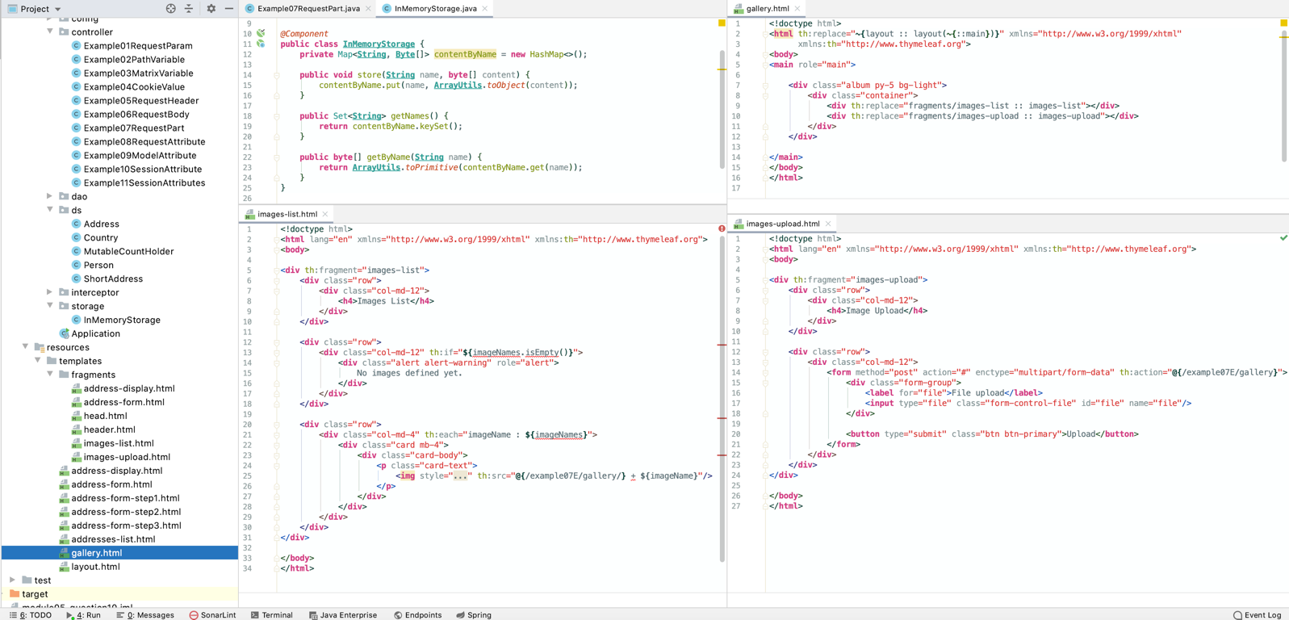

@RequestAttribute–allows access to HTTP request attributes populated on server-side during HTTP request by filter or interceptor, can be made optional with usage of required attribute or Java 8 Optional

*@Controller***public class Example08RequestAttribute** *{  
  
 // curl http://localhost:8080/example08A  
 @GetMapping(*"/example08A"*)  
 @ResponseBody* **public String** example08A*(@RequestAttribute(*"processing-time"*)* **String** processingTime*) {* **return String**.*format(*"processing time = [%s]\n", processingTime*)*;  
 *}  
  
 // curl http://localhost:8080/example08B  
 @GetMapping(*"/example08B"*)  
 @ResponseBody* **public String** example08B*(@RequestAttribute(*"processing-time"*)* **LocalDateTime** processingTime*) {* **return String**.*format(*"processing time = [%s]\n", processingTime*)*;  
 *}  
  
 // curl http://localhost:8080/example08C  
 @GetMapping(*"/example08C"*)  
 @ResponseBody* **public String** example08C*(@RequestAttribute(*value = "non-existing-processing-time", required = **false***)* **LocalDateTime** processingTime*) {* **return String**.*format(*"processing time = [%s]\n", processingTime*)*;  
 *}  
  
 // curl http://localhost:8080/example08D  
 @GetMapping(*"/example08D"*)  
 @ResponseBody* **public String** example08D*(@RequestAttribute(*value = "non-existing-processing-time", required = **false***)* **Optional***<***LocalDateTime***>* processingTime*) {* **return String**.*format(*"processing time = [%s]\n", processingTime.orElse*(***LocalDateTime**.***MIN****))*;  
 *}  
}*

*@Component***public class RequestTimeInterceptor implements** HandlerInterceptor *{  
 @Override* **public boolean** preHandle*(*HttpServletRequest request, HttpServletResponse response, **Object** handler*)* **throws Exception** *{* request.setAttribute*(*"processing-time", **LocalDateTime**.*now())*;  
  
 **if** *(*request.getSession*()*.getAttribute*(*"mutableCountHolder"*)* == **null***)* request.getSession*()*.setAttribute*(*"mutableCountHolder", **new** MutableCountHolder*())*;  
  
 **return true**;  
 *}  
}*

@ModelAttribute-access to an existing attribute in the model (instantiated if not present) with data binding and validation applied

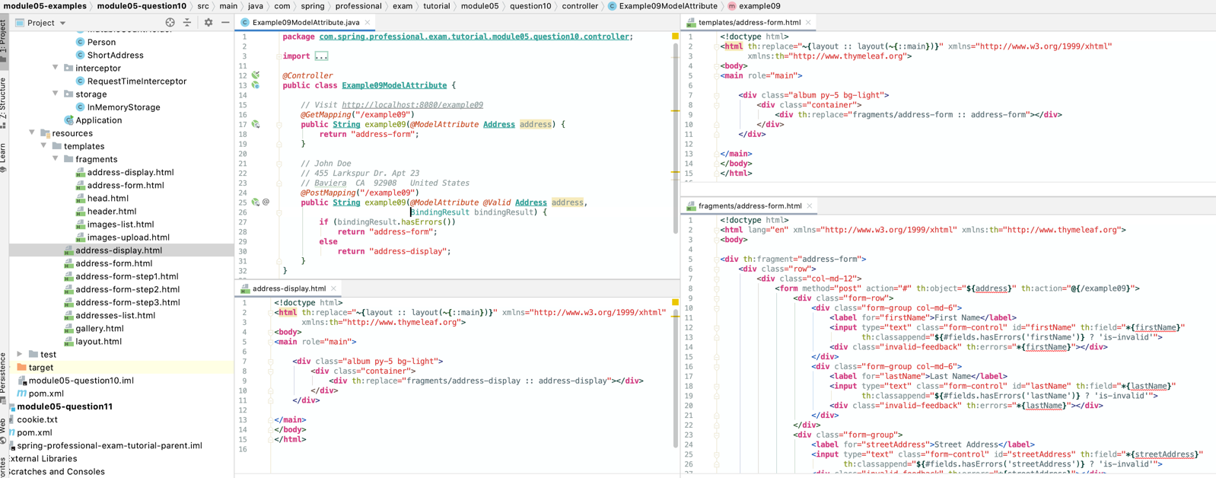

@SessionAttribute-access to pre-existing session attributes that are managed globally, can be made optional with usage of requiredattribute or Java 8 Optional

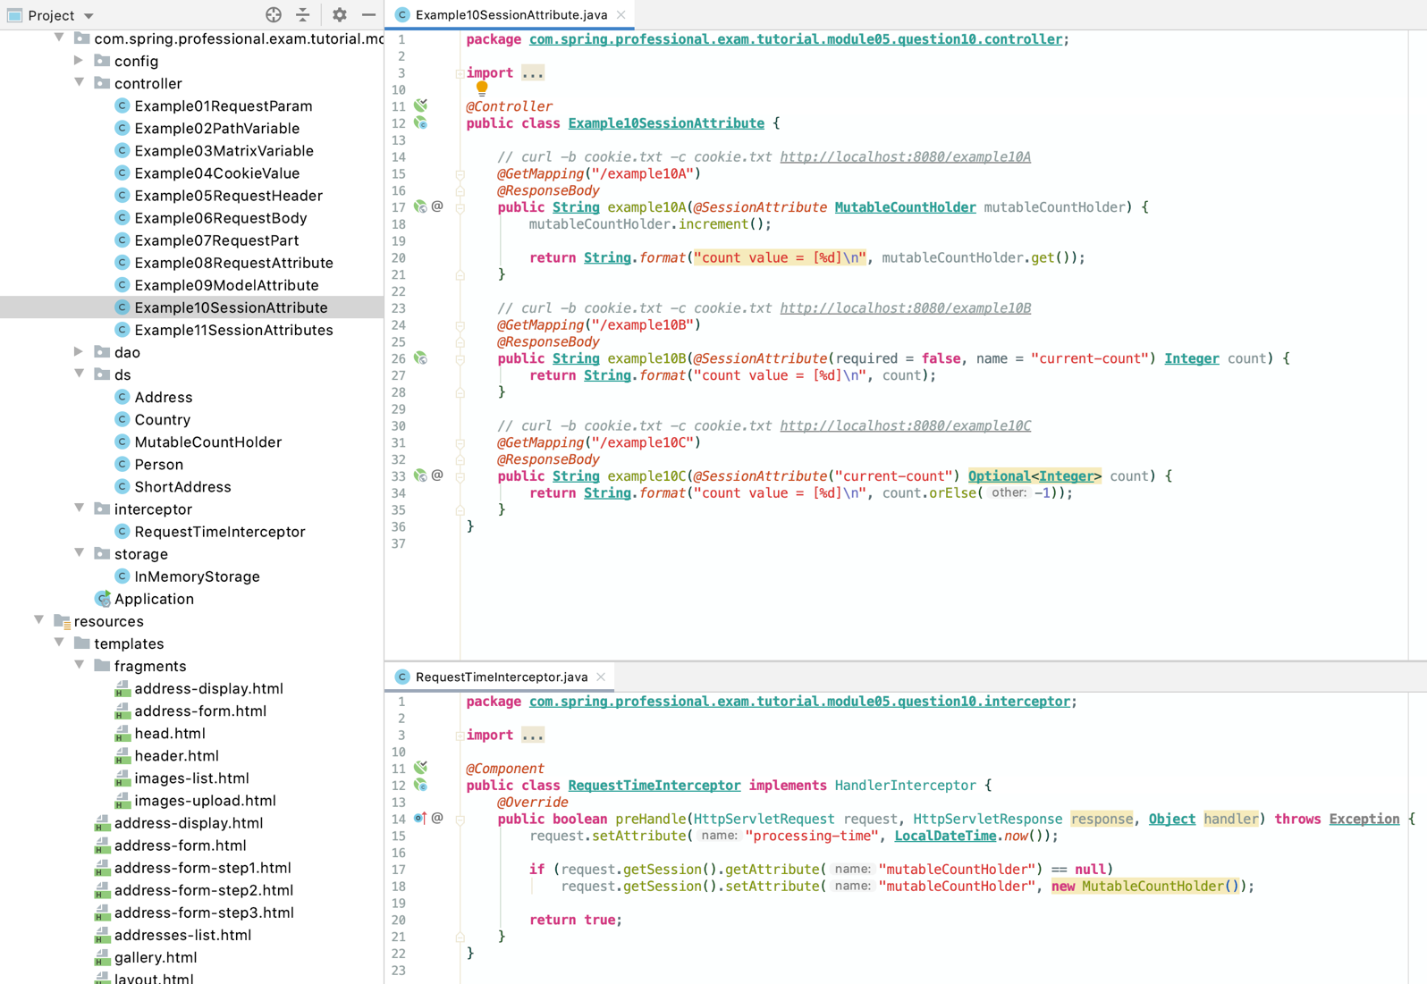

@SessionAttributes-used to store model attributes in the HTTP Servlet session between requests, useful for multi step from processing

*@Controller  
@SessionAttributes({*"person", "shortAddress", "country"*})***public class Example11SessionAttributes** *{  
  
 @Autowired* **private** AddressDao addressDao;  
  
 *// Visit http://localhost:8080/example11 in your browser  
 // John Doe  
 // 455 Larkspur Dr. Apt 23  
 // Baviera CA 92908 United States  
 @GetMapping(*"/example11"*)* **public String** example11*(*Model model*) {* model.addAttribute*(*"addresses", addressDao.findAll*())*;  
  
 **return** "addresses-list";  
 *}  
  
 // This is a first step in multi step address submission  
 @GetMapping(*"/example11/address/step1"*)* **public String** example11Step1*(@ModelAttribute(*"person"*)* **Person** person*) {* **return** "address-form-step1";  
 *}  
  
 // This is a post submission method for first step of multi step address submission  
 @PostMapping(*"/example11/address/step1"*)* **public String** example11Step1*(@ModelAttribute(*"person"*) @Valid* **Person** person, BindingResult bindingResult*) {* **if** *(*bindingResult.hasErrors*())* **return** "address-form-step1";  
 **else  
 return** "redirect:/example11/address/step2";  
 *}  
  
 // This is a second step in multi step address submission  
 @GetMapping(*"/example11/address/step2"*)* **public String** example11Step2*(@ModelAttribute(*"shortAddress"*)* **ShortAddress** shortAddress*) {* **return** "address-form-step2";  
 *}  
  
 // This is a post submission method for second step of multi step address submission  
 @PostMapping(*"/example11/address/step2"*)* **public String** example11Step2*(@ModelAttribute(*"shortAddress"*) @Valid* **ShortAddress** shortAddress, BindingResult bindingResult*) {* **if** *(*bindingResult.hasErrors*())* **return** "address-form-step2";  
 **else  
 return** "redirect:/example11/address/step3";  
 *}  
  
 // This is a third step in multi step address submission  
 @GetMapping(*"/example11/address/step3"*)* **public String** example11Step3*(@ModelAttribute(*"country"*)* **Country** country*) {* **return** "address-form-step3";  
 *}  
  
 // This is a post submission method for third step of multi step address submission  
 @PostMapping(*"/example11/address/step3"*)* **public String** example11Step3*(@ModelAttribute(*"country"*) @Valid* **Country** country,  
 BindingResult bindingResult,  
 *@ModelAttribute(*"shortAddress"*)* **ShortAddress** shortAddress,  
 *@ModelAttribute(*"person"*)* **Person** person, SessionStatus sessionStatus*) {* **if** *(*bindingResult.hasErrors*())* **return** "address-form-step3";  
 **else** *{* **Address** address = **new** Address*(*person, shortAddress, country*)*;  
 addressDao.save*(*address*)*;  
 sessionStatus.setComplete*()*;  
  
 **return** "redirect:/example11";  
 *}  
 }  
  
 @ModelAttribute(*"person"*)* **public Person** person*() {* **return new** Person*()*;  
 *}  
  
 @ModelAttribute(*"shortAddress"*)* **public ShortAddress** shortAddress*() {* **return new** ShortAddress*()*;  
 *}  
  
 @ModelAttribute(*"country"*)* **public Country** country*() {* **return new** Country*()*;  
 *}  
}*

# Question 11-What are some of the valid return types of a controller method?

@ResponseBody–binds method return value to web response body, complex types will be converted with usage of HttpMessageConverter using reflection

*@Controller***public class Example01ResponseBody** {  
  
 *// curl http://localhost:8080/example01A  
 @GetMapping*("/example01A")   
 *@ResponseBody* **public String** example01A() *{* **return** "Response Content from example01A\n";  
 *}  
  
 // curl http://localhost:8080/example01B  
 @GetMapping*("/example01B")  
 *@ResponseBody //displayed as json,* **public Person** example01B() *{* **return new** Person("John", "Doe");  
 *}*}

HttpEntity<B>, ResponseEntity<B>-allows to specify full response with headers and body, ResponseEntity<B> additionally allows you to specify HTTP status code

*@Controller***public class Example02Entity** {  
  
 *// curl -D - http://localhost:8080/example02A  
 @GetMapping*("/example02A")  
 **public HttpEntity**<**Person**> example02A() *{* **HttpHeaders** httpHeaders = **new** HttpHeaders();  
 httpHeaders.set("Person-Version", "v2");  
  
 **return new** HttpEntity<>(  
 **new** Person*(*"John", "Doe"*)*,  
 httpHeaders  
 );  
 *}  
  
 // curl -D - http://localhost:8080/example02B  
 @GetMapping*("/example02B")  
 **public ResponseEntity**<**Person**> example02B() *{* **HttpHeaders** httpHeaders = **new** HttpHeaders();  
 httpHeaders.set("Person-Version", "v2");  
  
 **return new** ResponseEntity<>(  
 **new** Person*(*"John", "Doe"*)*,  
 httpHeaders,  
 HttpStatus.***FOUND*** );  
 *}*}

HttpHeaders–allows to return response only with headers, without body

*@Controller***public class Example03HttpHeaders** {  
  
 *// curl -D - http://localhost:8080/example03  
 @GetMapping*("/example03")  
 **public HttpHeaders** example03() *{* **HttpHeaders** httpHeaders = **new** HttpHeaders();  
 httpHeaders.set("API-Version", "v3");  
 httpHeaders.setDate(**System**.*currentTimeMillis*());  
 httpHeaders.setContentType(**MediaType**.***APPLICATION_XML***);  
  
 **return** httpHeaders;  
 *}*}

String–allows to return logical name of view to use when rendering response, view will be resolved by ViewResolver, usually used with implicit model through @ModelAttributeparameters or explicit model by declaring Model method parameter

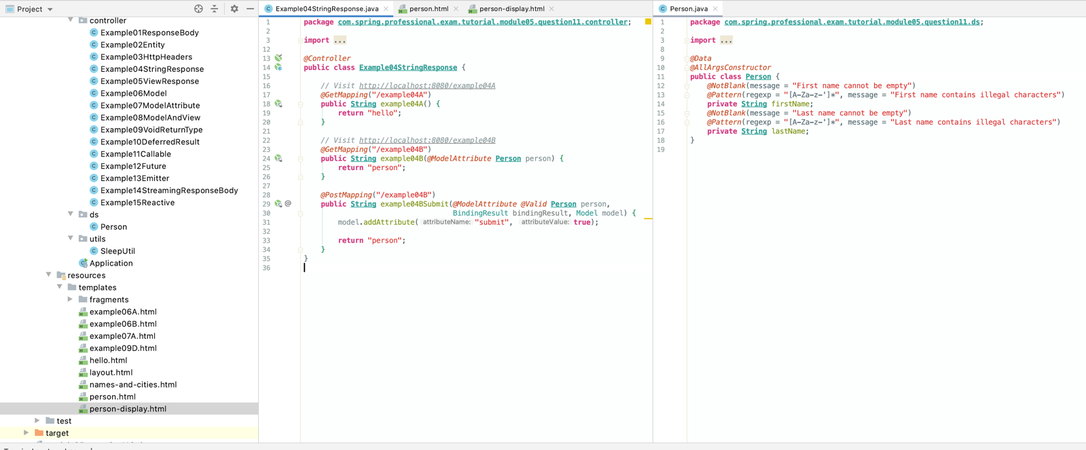

View–allows to return instance of view, like JstlView, ThymeleafView, FreeMarkerView, usually used with implicit model through @ModelAttributeparameters or explicit model by declaring Model method parameter – example below gives same result as previous.

*@Controller***public class Example05ViewResponse** {  
  
 *@Autowired* **private ThymeleafViewResolver** thymeleafViewResolver;  
  
 *// Visit http://localhost:8080/example05A  
 @GetMapping*("/example05A")  
 **public** View example05A() **throws Exception** *{* **return** thymeleafViewResolver.resolveViewName("hello", **Locale**.*getDefault*());  
 *}  
  
 // Visit http://localhost:8080/example05B  
 @GetMapping*("/example05B")  
 **public** View example05B(*@ModelAttribute* **Person** person) **throws Exception** *{* **return** thymeleafViewResolver.resolveViewName("person", **Locale**.*getDefault*());  
 *}  
  
 @PostMapping*("/example05B")  
 **public** View example05BSubmit(*@ModelAttribute @Valid* **Person** person, BindingResult bindingResult, Model model) **throws Exception** *{* model.addAttribute("submit", **true**);  
  
 **return** thymeleafViewResolver.resolveViewName("person", **Locale**.*getDefault*());  
 *}*}

Map, Model–allows you to specify attributes to be added to the implicit model, with the view name implicitly determined through a RequestToViewNameTranslator examples below give the same result

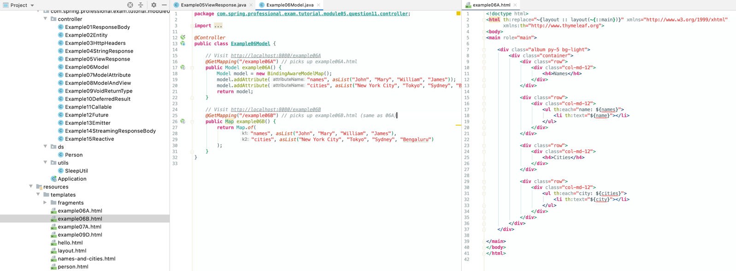

@ModelAttribute–allows you to specify an attribute to be added to the model, with the view name implicitly determined through a RequestToViewNameTranslator

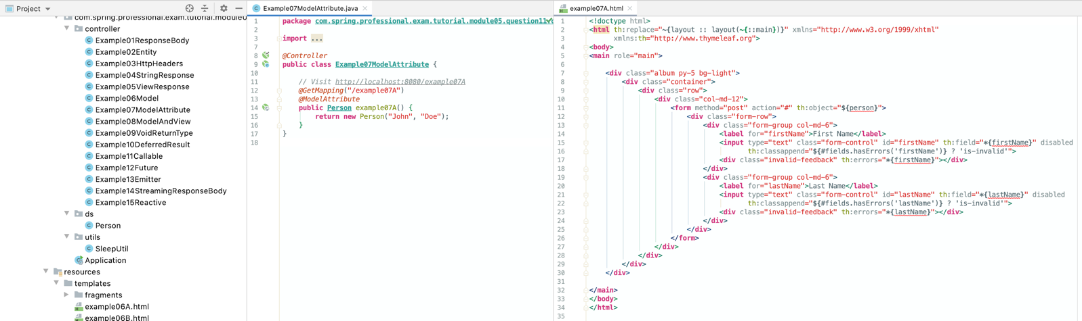

ModelAndView-view and model attributes to use and, optionally, a response status, view can be specified by logical name or instance of view can be passed, model can be specified as named object or Map

*@Controller***public class Example08ModelAndView** {  
  
 *// Visit http://localhost:8080/example08A  
 @GetMapping*("/example08A")  
 **public ModelAndView** example08A() *{* **return new** ModelAndView(  
 "person-display",  
 "person",  
 **new** Person*(*"John", "Doe"*)* );  
 *}  
  
 // Visit http://localhost:8080/example08B  
 @GetMapping*("/example08B")  
 **public ModelAndView** example08B() *{* **return new** ModelAndView(  
 "names-and-cities",  
 Map.*of(* "names", *asList(*"John", "Mary", "William", "James"*)*,  
 "cities", *asList(*"New York City", "Tokyo", "Sydney", "Bengaluru"*)  
 )*,  
 HttpStatus.***OK*** );  
 *}*}

void–method that returns void can correctly handle request by using ServletResponseor OutputStreamas parameter, or @ResponseStatusannotation, if none of previous are used RequestToViewNameTranslator will identify view based on request, void return type can also indicate “no response body” for REST controllers

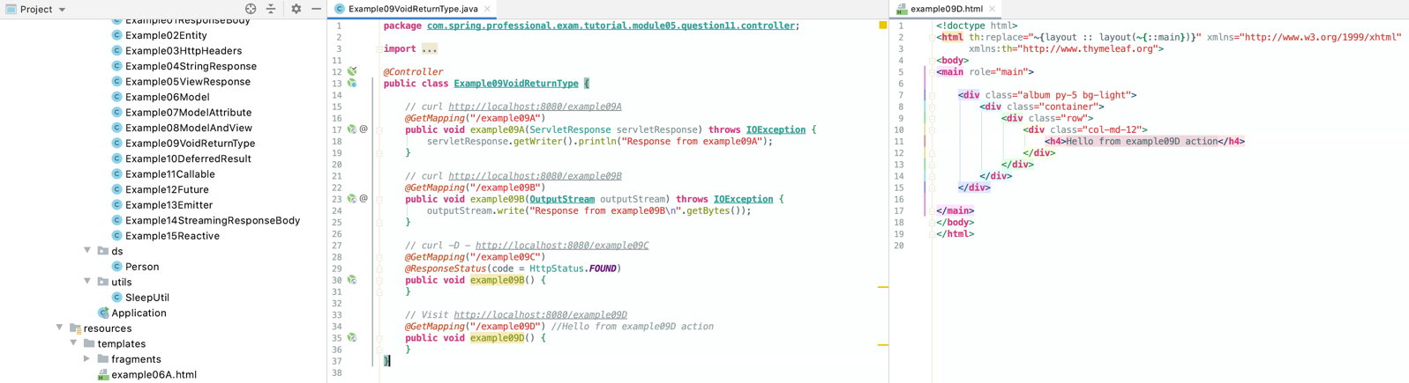

DeferredResult<V> -allows to specify result for controller asynchronously from different Thread or as result of some event callback, part of integration with Servlet 3.0 asynchronous request

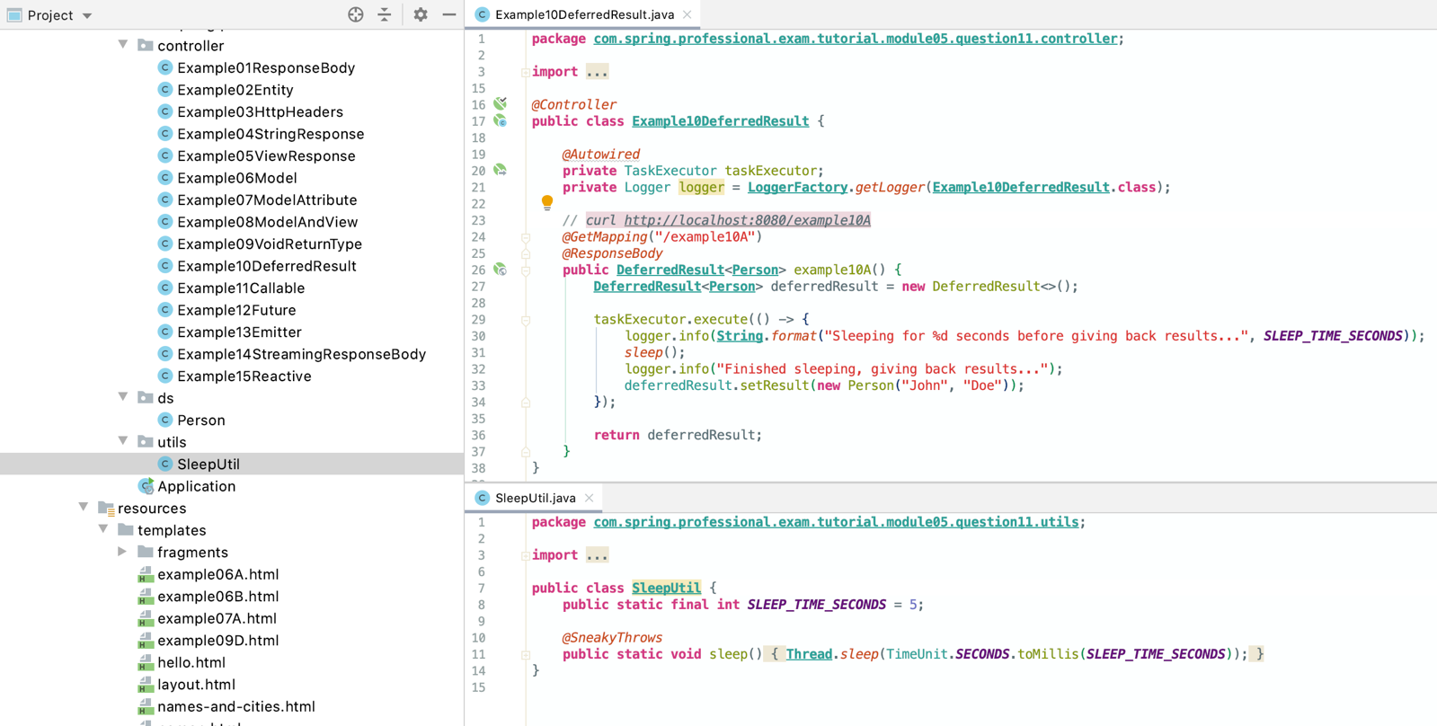

Callable<V> -allows to produce return value asynchronously in a Spring MVC-managed thread

*@Controller***public class Example11Callable** {  
  
 **private** Logger logger = **LoggerFactory**.*getLogger*(**Example11Callable**.**class**);  
  
 *// curl http://localhost:8080/example11A  
 @GetMapping*("/example11A")  
 *@ResponseBody* **public** Callable<**Person**> example11A() *{* **return** () -> *{* logger.info(**String**.*format(*"Pretending to run long operation for %d seconds in thread %s", ***SLEEP_TIME_SECONDS***, **Thread**.*currentThread*().getName()*)*);  
 *sleep*();  
 logger.info("Pretended long operation finished, returning value...");  
  
 **return new** Person("John", "Doe");  
 *}*;  
 *}*}

ListenableFuture<V>,CompletableFuture<V>, CompletionStage<V>-allows to return set of chained, asynchronous operations, with callbacks and transformations

*@Controller***public class Example12Future** {  
  
 *@Autowired* **private** TaskExecutor taskExecutor;  
 **private** Logger logger = **LoggerFactory**.*getLogger*(**Example12Future**.**class**);  
  
 *// curl http://localhost:8080/example12A  
 @GetMapping*("/example12A")  
 *@ResponseBody* **public** ListenableFuture<**Person**> example12A() *{* **ListenableFutureTask**<**Person**> listenableFutureTask = **new** ListenableFutureTask<>(() -> *{* logger.info*(***String**.*format(*"Pretending to run long operation for %d seconds in thread %s", ***SLEEP_TIME_SECONDS***, **Thread**.*currentThread*().getName()*))*;  
 *sleep*();  
 logger.info*(*"Pretended long operation finished, returning value..."*)*;  
  
 **return new** Person*(*"John", "Doe"*)*;  
 *}*);  
  
 listenableFutureTask.addCallback(**new ListenableFutureCallback**<>() *{  
 @Override* **public void** onSuccess*(***Person** person*) {* logger.info*(***String**.*format(*"Task created person = [%s]", person*))*;  
 *}  
  
 @Override* **public void** onFailure*(***Throwable** ex*) {* logger.info*(***String**.*format(*"Exception thrown by task = [%s]", ex.getMessage()*))*;  
 *}  
 }*);  
  
 taskExecutor.execute(listenableFutureTask);  
  
 **return** listenableFutureTask;  
 *}  
  
 // curl http://localhost:8080/example12B  
 @GetMapping*("/example12B")  
 *@ResponseBody* **public CompletableFuture**<**Integer**> example12B() *{* **CompletableFuture**<**Person**> completableFuture = **CompletableFuture**.*supplyAsync*(() -> *{* logger.info*(***String**.*format(*"Pretending to run long operation for %d seconds in thread %s", ***SLEEP_TIME_SECONDS***, **Thread**.*currentThread*().getName()*))*;  
 *sleep*();  
 logger.info*(*"Pretended long operation finished, returning value..."*)*;  
  
 **return new** Person*(*"John", "Doe"*)*;  
 *}*);  
  
 **return** completableFuture  
 .thenApply(person -> **String**.*format(*"%s %s", person.getFirstName(), person.getLastName()*)*)  
 .thenApply(**String**::length);  
 *}  
  
 // curl http://localhost:8080/example12C  
 @GetMapping*("/example12C")  
 *@ResponseBody* **public** CompletionStage<**String**> example12C() *{* CompletionStage<**Person**> completionStage = **CompletableFuture**.*supplyAsync*(() -> *{* logger.info*(***String**.*format(*"Pretending to run long operation for %d seconds in thread %s", ***SLEEP_TIME_SECONDS***, **Thread**.*currentThread*().getName()*))*;  
 *sleep*();  
 logger.info*(*"Pretended long operation finished, returning value..."*)*;  
  
 **return new** Person*(*"John", "Doe"*)*;  
 *}*);  
  
 **return** completionStage  
 .thenApply(person -> **String**.*format(*"%s %s", person.getFirstName(), person.getLastName()*)*)  
 .thenApply(**String**::toUpperCase);  
 *}*}

ResponseBodyEmitter, SseEmitter–allows to send objects in stream asynchronously, objects will be converted with usage of HttpMessageConverter, can be used with ResponseEntity, both classes have the same goal, however SseEmitteruses Server-Sent Events standardized with W3C SSE specification

*@Controller***public class Example13Emitter** {  
  
 *@Autowired* **private** TaskExecutor taskExecutor;  
  
 *// curl -D - http://localhost:8080/example13A  
 @GetMapping*("/example13A")  
 *@ResponseBody* **public ResponseBodyEmitter** example13A() *{* **ResponseBodyEmitter** emitter = **new** ResponseBodyEmitter();  
  
 **CompletableFuture**<**Void**> completableFuture = **CompletableFuture** .*runAsync*(() -> *{* send*(*emitter, **new** Person*(*"John", "Doe"*)*, ***APPLICATION_JSON****)*;  
 *}*)  
 .thenRunAsync(() -> *{* send*(*emitter, **new** Person*(*"William", "Anderson"*)*, ***APPLICATION_JSON****)*;  
 *}*)  
 .thenRun(emitter::complete);  
  
 taskExecutor.execute(completableFuture::join);  
  
 **return** emitter;  
 *}  
  
 // curl -D - http://localhost:8080/example13B  
 @GetMapping*("/example13B")  
 *@ResponseBody* **public SseEmitter** example13B() *{* **SseEmitter** emitter = **new** SseEmitter();  
  
 **CompletableFuture**<**Void**> completableFuture = **CompletableFuture** .*runAsync*(() -> *{  
 sleep*();  
 send*(*emitter, **new** Person*(*"William", "Anderson"*)*, ***APPLICATION_JSON****)*;  
 *}*)  
 .thenRunAsync(() -> *{  
 sleep*();  
 send*(*emitter, **new** Person*(*"John", "Doe"*)*, ***APPLICATION_JSON****)*;  
 *}*)  
 .thenRun(emitter::complete);  
  
 taskExecutor.execute(completableFuture::join);  
  
 **return** emitter;  
 *}  
  
 @SneakyThrows* **private void** send(**ResponseBodyEmitter** emitter, **Object** object, **MediaType** mediaType) *{* emitter.send(object, mediaType);  
 *}*}

StreamingResponseBody–allows to write to the response OutputStream asynchronously

*@Controller***public class Example14StreamingResponseBody** {  
  
 *// curl http://localhost:8080/example14  
 @GetMapping*("/example14")  
 **public** StreamingResponseBody example14() *{* **return new StreamingResponseBody**() *{  
 @Override* **public void** writeTo(**OutputStream** outputStream) **throws IOException** *{* outputStream.write("John".getBytes());  
 outputStream.write("Doe".getBytes());  
 *}  
 }*;  
 *}*}

Reactive types–allows to use Reactive types for streaming scenarios, handled by ReactiveAdapterRegistry

*@Controller***public class Example15Reactive** {  
  
 *@Autowired* **private** TaskExecutor taskExecutor;  
  
 *// curl -D - http://localhost:8080/example15  
 @GetMapping*("/example15")  
 *@ResponseBody* **public Observable**<**Person**> example15() *{* **PublishSubject**<**Person**> subject = **PublishSubject**.*create*();  
  
 taskExecutor.execute(() -> *{  
 sleep*();  
  
 subject.onNext*(***new** Person*(*"John", "Doe"*))*;  
 subject.onNext*(***new** Person*(*"William", "Anderson"*))*;  
  
 subject.onComplete();  
 *}*);  
  
 **return** subject;  
 *}*}